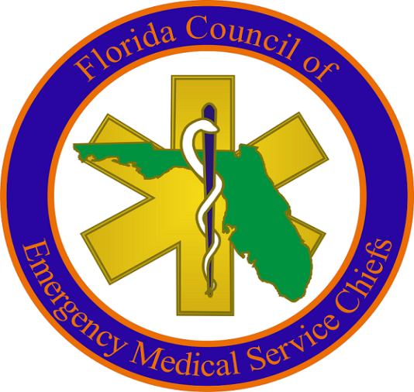
Expertise, Foresight, Initiative.
AGENDA
January 21, 2016, 1000 hours
The Plaza Resort & Spa
101 North Atlantic Avenue
Daytona Beach, FL 32118

1. Welcome – Mac Kemp, President
2. Approval of Minutes of November 17, 2015 Meeting
3. President Report – Mac Kemp
3. New Legislation
4. Old Business
5. New Business
6. Adjournment

