INSTRUCTIONS

Closed POD Preparation and Practice



Contents
Where Do I Start? 2
Overview Meeting 2
Tabletop Exercise 2
Functional Exercise 3
Exercise Evaluation 4
Closed POD Planning Kit 5
For More Information about the Documents 5
Preparation and Practice 6
The After Action Report (AAR) 11
What is an After Action Report? 11
After Action Administration 11
How to Complete the After Action Report 11
After Action Report Sample Content 14
Appendix • Document Index 17
Planning Tools 17
Preparation and Practice 17
Closed POD Operations 18

Where Do I Start?
This document provides an overview of the Preparation and Practice components of the Closed POD Planning Kit. Documents are supplied for three different events, described below. These events build on one another. They are designed to be conducted with your property in the sequence they appear below.

Overview Meeting

Closed POD Overview Meeting. It is strongly recommended that your Closed POD command team attend a meeting where the Closed POD Primary Command Coordinator facilitates this material. The objectives of this session include:

- Ensuring your Command Team's understanding of the Closed POD Plan,
- Knowing where to locate the Closed POD resources and making sure your Command Team:
- Knows their roles, responsibilities and tasks – both for planning and on the day of an event.
- Knows how an Incident Command System works – how and what is important to communicate in this system.
- Understands Closed POD process phases – beginnings, endings, and phase “triggers.”
- Uses Closed POD terms correctly now, so if an emergency occurs, everyone will speak the same language.

Tabletop Exercise

Closed POD Tabletop Exercise. The tabletop exercise is a discussion based exercise and provides an opportunity for your Command Team to review and test the property’s plan. It’s your chance to find the holes and gaps in your plan so they can be remedied before an actual emergency occurs. The goal of the tabletop exercise is three-fold:
- To demonstrate viability of the Closed POD Plan.
- To use the results to update and improve the plan.
- To educate the responsible parties on their roles and tasks carrying out the plan.

Functional Exercise

Closed POD Functional Exercise. The functional exercise is an “on your feet” practice session that simulates a real emergency. The goal is to test how your plan works in practice, test all operational functions of the Closed POD Plan, and increase the level of confidence enacting the plan. Specifically, your property will test:
- Command Team direction and control
- Decision-making processes
- The strength of plans, policies, procedures, and roles
- Individual and system performance
- Incident Command structure and communication effectiveness
- Allocation of resources and personnel to adequately meet the emergency situation

Exercise Evaluation
When testing your plan through either a tabletop or functional exercise, it’s essential to evaluate the activity to identify what went well and what needs improvement. Specific evaluation forms are included in the kit for each type of exercise. Instructions for using the evaluations are found in the evaluation documents.

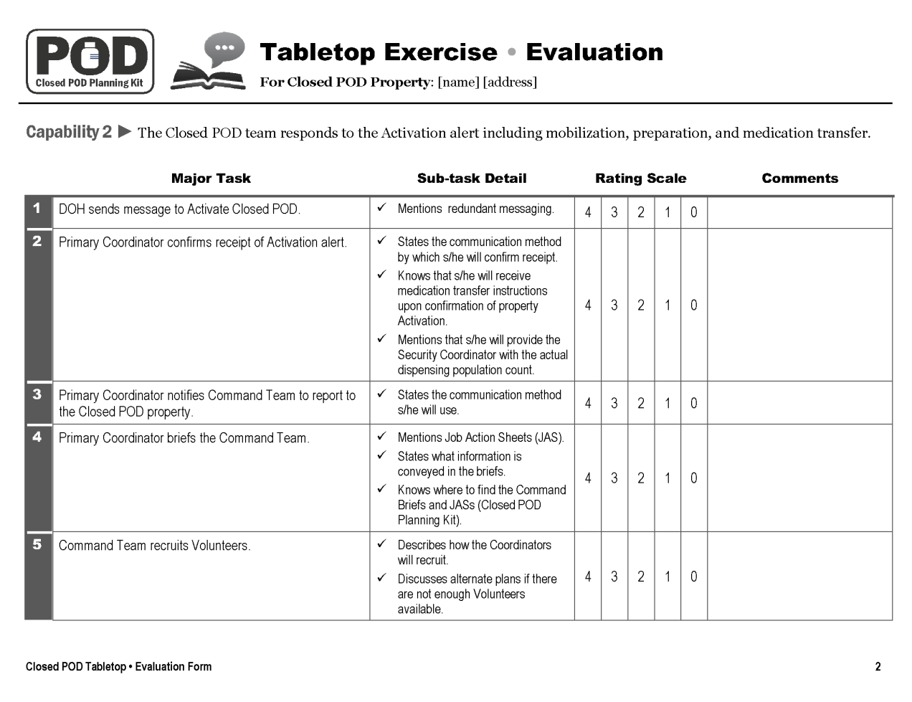

Closed POD Planning Kit
The Closed POD Planning Kit is delivered in a Zip file with three main folders, shown in the table below.
 | Planning Tools  Documents used during the Closed POD Planning phase.
Preparation and Practice
A module to prepare leaders to take on Closed POD roles. Also, a collection of exercises and tools used to evaluate Closed POD Plan effectiveness and practice the plan.
Closed POD Operations
All the files you’ll need on the day(s) you operate a Closed POD.

For More Information about the Documents
Thumbnail images and descriptions of each document are found in Preparation and Practice
The complete list of files with their filenames can be found in the Appendix • Document Index on page 19.

Preparation and Practice
What’s In the Preparation and Practice Folder • How to
Use It
All files are in Microsoft Office format, and use standard Windows fonts.

Folder Component | How To Use It | Item Thumbnail
OVERVIEW DOCUMENTS
Closed POD Overview Meeting Facilitator’s Guide  - Use these Overview modules to transfer knowledge from the planning process and prepare the property’s Command Coordinators for tabletop and functional exercises.  - Use the facilitator’s guide to plan, prepare and conduct the Overview Meeting. | 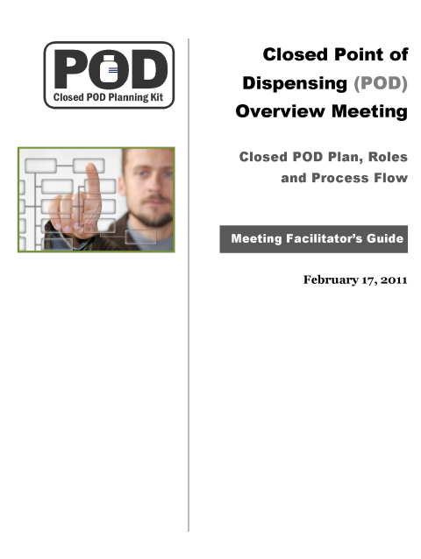
Closed POD Overview Meeting PowerPoint presentation  - Use the PowerPoint presentation to conduct the Closed POD Overview Meeting. | 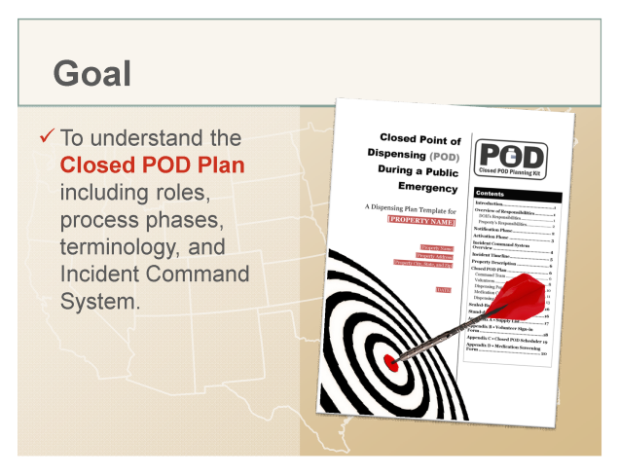
TABLETOP EXERCISE DOCUMENTS
Closed POD Tabletop Exercise Facilitator’s Guide  - The Facilitator’s Guide contains guidance, lesson plans, and discussion questions for facilitating a successful tabletop exercise.  - Use the facilitator’s guide to plan, prepare and conduct the tabletop exercise. | 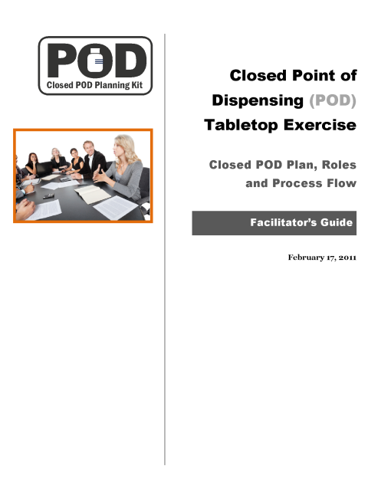
Closed POD Tabletop Exercise PowerPoint Presentation  - Use the PowerPoint presentation to conduct the Closed POD tabletop exercise. | 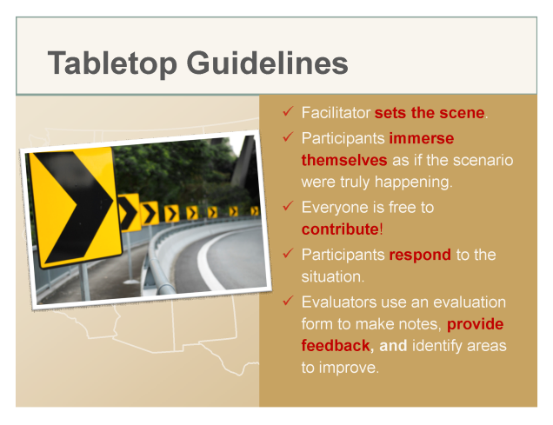
Closed POD Tabletop Exercise Evaluation Form  - Instructions and easy-to-use forms for those who are evaluating the tabletop exercise.  - Print one copy for each evaluator. | 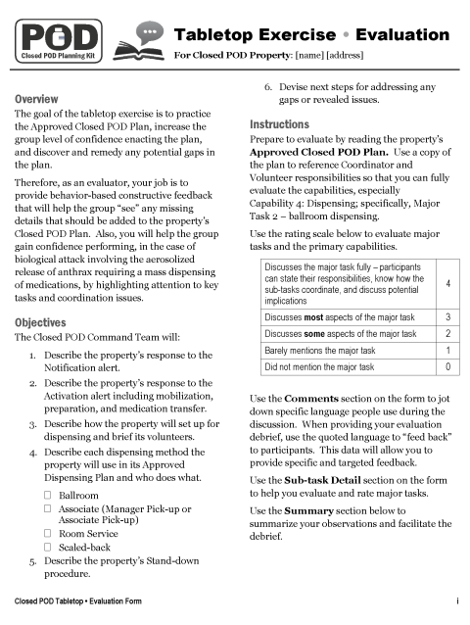
FUNCTIONAL EXERCISE DOCUMENTS
Closed POD Functional Exercise Facilitator’s Guide  - The Facilitator’s Guide contains guidelines, set-up instructions and checklists, and discussion questions for facilitating a successful functional exercise.  - Use the facilitator’s guide to plan, prepare, and facilitate the functional exercise. | 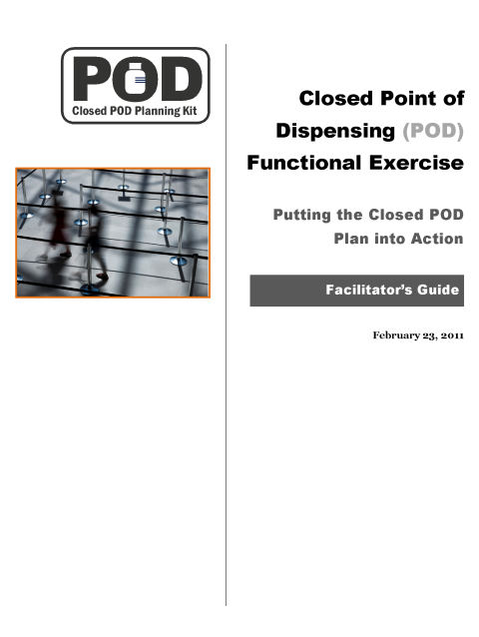
Closed POD Functional Exercise PowerPoint Presentation  - Use the PowerPoint presentation to launch the exercise and again when the exercise is debriefed. | 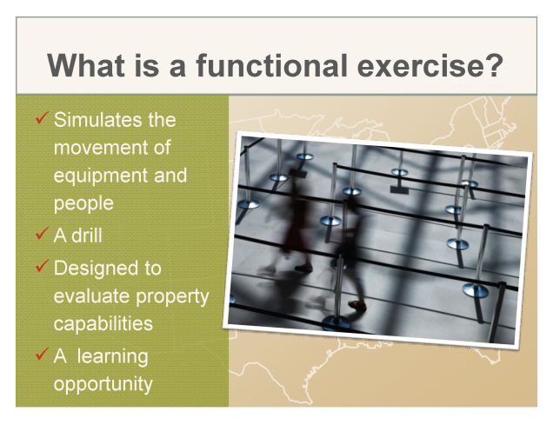
Closed POD Functional Exercise Evaluation Form  - Instructions and easy-to-use forms for those who are evaluating the functional exercise.  - Print one copy for each evaluator. | 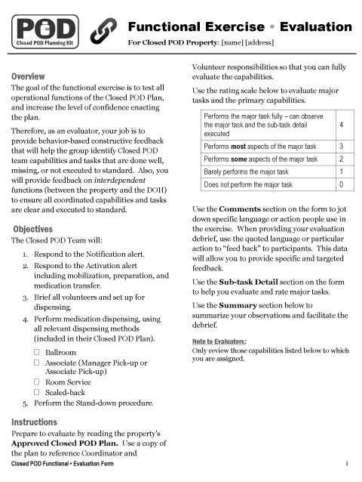
- Closed POD After Action Report (AAR)  - Use this Word document as a template when creating an After Action Report for either the tabletop or functional exercise.  - Refer to the instructions on page 13. | 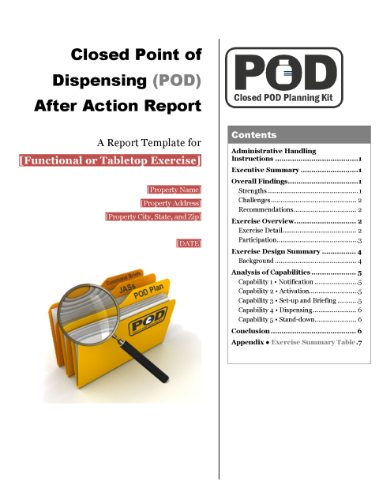

The After Action Report (AAR)

What is an After Action Report?
The After Action Report is your property’s description of the practice exercise and your compiled evaluation (from your notes, participants’ comments, and evaluators’ feedback). The report records the group’s Closed POD performance and plans for improvement. The report also communicates your property’s status to the DOH.

After Action Administration
The Primary coordinator has the responsibility to ensure that this report is created and submitted to your local DOH. Decide who will write the report—the lead evaluator, Primary Coordinator, or other person. Once the designated person has written the report, circulate the draft AAR to all Command Coordinators for their comments and feedback. Use a sign-off process so you know that each stakeholder has contributed appropriately to the report and understands any changes to your property’s Closed POD Plan. Once the report is finalized, submit it to the DOH, and don’t forget to update your property’s plan as needed.

How to Complete the After Action Report
 | Do this | Illustration • Note(s)
1 | In Microsoft Word, open the file:  09_closed_pod_aar_  template.doc | The AAR template document is created in Microsoft Word 2002/2003 format and will open in Word 2007/2010 in Compatibility Mode.
2 | Use the File, Save As command to save a copy of the document with the name:  closed_pod_aar_  property_name_date.doc | You may wish to create a separate folder on your computer for After Action Reports.
3 | To help with the editing process, set the Show/Hide icon to Show.  When set to Show, you’ll be able to see the paragraph end marks in your document. | When set to the “Show” position, the icon appears “pushed in.” Here’s where to find the Show/Hide icon:  Word 2002/2003: On the Standard toolbar.  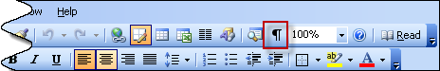  Word 2007/2010: In the Paragraph section on the Home Ribbon.  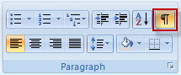
4 | Edit the text [Functional or Tabletop Exercise] to reflect the type of exercise your report represents. Delete the opening and closing brackets [ ] as well.  Note that this line is linked to the footer. As you make this change, the footer will update automatically. | 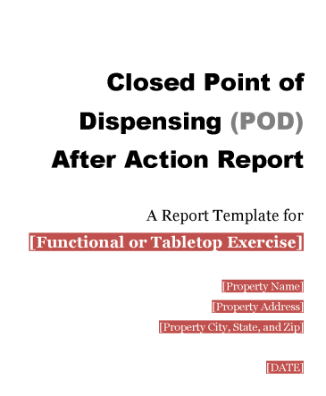
5 | Replace all red-shaded variables in the body of the document with your own information.  All variable information displays with red shading and white text.  Use the mouse or cursor keys to highlight each variable block, and type over the selection with your data.  Save your document frequently as you work. | 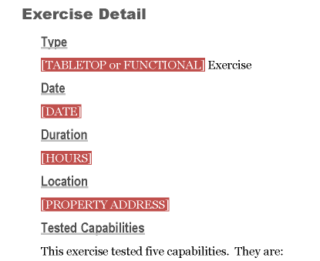  Leave the red shading in place until your document is nearly final. This way, if you need to make further edits to the variable information, you’ll be able to find it easily. Steps 7 and 8 tell you how to easily remove the shading from the entire document in one quick operation.
6 | Address all instructions and decision points in the document. Instructions display in red italicized text.  Some of these sections are labeled with [BEGIN CHOICE] instructions and [END CHOICE] markers.  Review the instructions for each decision point. Input the requested information or delete information that does not apply to your property.  Delete the instruction paragraphs after completing the suggested edits. Include the paragraph mark in your selection. | 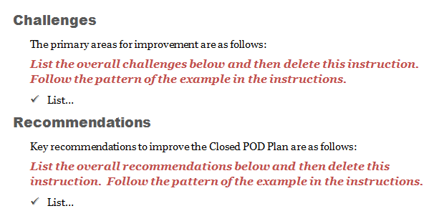  Including the paragraph mark when you select and delete a paragraph helps keep the document format intact. The paragraph mark is like a container that “holds” all of the formatting instructions for the paragraph.
7 | Prepare to remove the red shading from the document.  Display the Styles Pane. | To display the Styles Pane:  Word 2002/2003: Choose Format, Styles and Formatting from the menu.  Word 2007/2010: Click the small arrow at the bottom right of the Styles Section on the Home Ribbon.  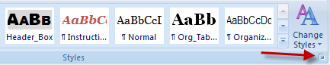
8 | Delete the Variables character style. Doing so removes all red shading from the document.  In the Styles Pane, locate the Variables style in the list.  Click the drop-down arrow to the right of the style.  Click Delete Variables…  Click Yes when prompted to confirm. | 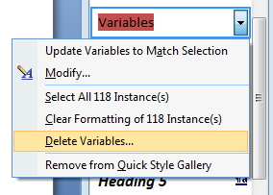  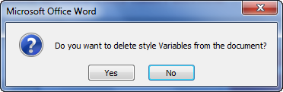
9 | Save the final AAR document.

After Action Report Sample Content
To help you complete your After Action Reports efficiently, use the selected sample content below, from previous After Action Reports, to guide your writing. Below you will find two sample sections: Overall Findings and Capability 1 • Notification.

Overall Findings

Strengths
Flexibility. The ABC Hotel adapted to changing conditions and quickly overcame obstacles and challenges, i.e., changes in room set-up, changes in POD volunteer roles.
Good use of available resources. ABC Hotel demonstrated innovative practices to capitalize on their organizational structure and resources.
Leadership of Primary Coordinator. The Primary Coordinator was calm which positively influenced the demeanor of his staff.

Challenges
Job Action Sheets (JAS). Not all players serving as volunteers followed their JASs (checklists of tasks).
Communication regarding medication receipt. There was miscommunication in regards to the drop-off point for the medication shipment.
Manager Pick-Up Dispensing method. Evaluators and players questioned the feasibility of this dispensing method because of bottleneck issues − too many managers trying to pick up medication at the same time.

Recommendations
Job Action Sheets (JAS). Print JASs on colored paper so that they are more easily identifiable. Use a checklist format so that volunteers can check off tasks one by one - helping ensure they complete all tasks.
Communication regarding medication receipt. Foster direct communication between the Security and Primary Coordinator. Streamline communication between one Coordinator and the delivery driver to synchronize the drop-off and improve medication security.
Manager Pick-Up Dispensing method. Test this method rigorously in the Functional exercise to more accurately determine its feasibility. Also, examine the feasibility of using the Ballroom method for associate medication dispensing.
Overall, the ABC Hotel Closed POD exercise was successful. Given ABC Hotel's demonstration of a strong culture for corporate responsibility, safety and customer service, they continue to be an extremely strong partner in the effort to dispense lifesaving medications in the event of a real emergency.

Capability 1: Notification

Analysis
Actions were timely and efficient. As one evaluator noted, the Primary Coordinator took approximately 20 minutes to prepare his command briefing, 15 minutes to get the word out to his Command Team, and another five minutes for his team coordinators to respond to his initial alert. Timing was similar for each of the four Team Coordinator responses. Evaluators and observers noted that the Primary Coordinator remained calm, and his demeanor was reflected in his Command Team. Although the Primary Coordinator confirmed receipt of the POD activation message, he did not provide the actual dispensing population number. However, the Primary Coordinator did provide this number when prompted by the DOH representative.

Conclusion
All in all, the staff who participated in this exercise performed outstandingly. There was great leadership, and a clear demonstration of ABC Hotel’s values of safety and customer service. Associates reported feeling comfortable with their specific job tasks and duties during the exercise. In order to create even more job task clarity, we recommend providing associates with critical task checklists, FAQ documents, and response scripts. In addition, we recommend that staff train further.
While the utility of the manager pick-up model is still under discussion, we are sure that ABC Hotel would implement the appropriate model or models given situational constraints. ABC Hotel was extremely flexible, identified problems quickly and utilized their resources efficiently. As one associate stated, “We deal with special circumstances on a daily basis.” Overall, our analysis supports the conclusion that this property is capable of operating a Closed POD.

Appendix • Document Index

 | Planning Tools
 | Item | File Name
 | Instructions and Tools for Closed POD Planning | 00_pod_planning_instructions.doc
 | Closed POD Definitions | 01_ pod_planning_definitions.doc
 | Closed POD Process Flow Diagram | 01_pod_planning_process_diagram.ppt
 | Property/DOH Discussion Guide | 02_ pod_planning_doh_discussion.doc
 | Closed POD Memorandum of Agreement (MOA) Template | 03_ pod_planning_moa_template.doc
 | Dispensing Plan Template | 04_ pod_dispensing_plan_template.doc
 | Associate Orientation (sample) | 05_ pod_planning_associate_orientation.doc
 | Manager Training (sample) | 05_ pod_planning_manager_training.doc
 | Signage Guidelines | 06_ pod_planning_signage_guide.doc

 | Preparation and Practice
 | Item | File Name
 | Instructions for using the tabletop and functional exercise documents | 00_closed_pod_exercise_instructions.doc
 | Facilitator Guide for the Closed POD overview meeting | 01_closed_pod_overview_fg.doc
 | PowerPoint presentation file for the Closed POD overview meeting | 02_closed_pod_overview_presentation.ppt
 | Facilitator Guide for the Closed POD tabletop exercise | 03_closed_pod_tabletop_fg.doc
 | PowerPoint presentation file for the Closed POD tabletop exercise | 04_closed_pod_tabletop_presentation.ppt
 | Evaluation form for the tabletop exercise | 05_closed_pod_tabletop_evaluation_form.doc
 | Facilitator Guide for the Closed POD functional exercise | 06_closed_pod_functional_fg.doc
 | PowerPoint presentation file for the Closed POD tabletop exercise | 07_closed_pod_functional_presentation.ppt
 | Evaluation form for the functional exercise | 08_closed_pod_functional_evaluation_form.doc
 | Template file for creating an After Action Report for either a tabletop or functional exercise | 09_closed_pod_aar_template.doc

 | Closed POD Operations
 | Item |  | File Name
 | Place final copy of MOA file in the Closed POD Operations folder, and name it as shown at right. |  | 01_closed_pod_moa_property_name.doc
 | Place final copy of approved dispensing plan file in the Closed POD Operations folder, and name it as shown at right. |  | 02_closed_pod_plan_property_name.doc
 | Command Brief to Command Team |  | 03_closed_pod_command_briefing_01_  commanders.doc
 | Command Brief to Volunteers |  | 03_closed_pod_command_briefing_02_  volunteers.doc
 | Command Brief from Security Coordinator to Team |  | 03_closed_pod_command_briefing_03_  security.doc
 | Command Brief from Logistics Coordinator to Team |  | 03_closed_pod_command_briefing_04_  logistics.doc
 | Command Brief from Human Resources Coordinator to Team |  | 03_closed_pod_command_briefing_05_  human_resources.doc
 | Command Brief from Business Continuity Coordinator to Team |  | 03_closed_pod_command_briefing_06_  business_continuity.doc
 | Job Action Sheet - Primary Coordinator |  | 04_closed_pod_job_action_sheet_01_  primary-coord.doc
 | Job Action Sheet – Security Coordinator |  | 04_closed_pod_job_action_sheet_02_  security-coord.doc
 | Job Action Sheet – Logistics Coordinator |  | 04_closed_pod_job_action_sheet_03_  logistics-coord.doc
 | Job Action Sheet – Human Resources Coordinator |  | 04_closed_pod_job_action_sheet_04_  hr-coord.doc
 | Job Action Sheet – Business Continuity Coordinator |  | 04_closed_pod_job_action_sheet_05_  business-coord.doc
 | Job Action Sheet – Associate Dispensing Coordinator |  | 04_closed_pod_job_action_sheet_06_  assoc-disp-coord.doc
 | Job Action Sheet – Greeter |  | 04_closed_pod_job_action_sheet_07_greeter.doc
 | Job Action Sheet – Screener |  | 04_closed_pod_job_action_sheet_08_screener.doc
 | Job Action Sheet – Dispenser |  | 04_closed_pod_job_action_sheet_09_  dispenser.doc
 | Job Action Sheet – Exit Monitor |  | 04_closed_pod_job_action_sheet_10_  exit_monitor.doc
 | Job Action Sheet – Security |  | 04_closed_pod_job_action_sheet_11_security.doc
 | Job Action Sheet – Maintenance |  | 04_closed_pod_job_action_sheet_12_  maintenance.doc
 | Job Action Sheet – Food Service Provider |  | 04_closed_pod_job_action_sheet_13_  food_service.doc
 | Job Action Sheet – Runner |  | 04_closed_pod_job_action_sheet_14_runner.doc
 | Job Action Sheet – Queue Control |  | 04_closed_pod_job_action_sheet_15_  queue_control.doc
 | Job Action Sheet – Room Service |  | 04_closed_pod_job_action_sheet_16_  room_service.doc
 | Form – Medication Screening Form, Cipro/Doxy |  | 05_closed_pod_form_medication_screen_  cipro_doxy.doc
 | Form – Medication Screening Form Job Aid |  | 05_closed_pod_form_medication_screen_  job_aid.doc
 | Form – Closed POD Scheduler |  | 05_closed_pod_form_scheduler.doc
 | Form – Volunteer Sign In Form |  | 05_closed_pod_form_sign-in_sheet.doc
 | Greeter’s Script |  | 06_closed_pod_greeters_script.doc
 | Day of Event Communication Matrix with Sample Messaging |  | 07_closed_pod_communications.doc
 | Public PowerPoint Presentation |  | 08_closed_pod_public_powerpoint.ppt
 |  | Signage | File names within the Signage folder are self-explanatory. Refer to the Signage Guidelines document for thumbnail images of all signs included in this folder.

