INSTRUCTIONS

How to Prepare and Assemble Your Closed POD Planning Kit



Contents
Where Do I Start? 2
Closed POD Planning Kit 2
Frequently Asked Questions 3
Closed POD Process Diagram 5
Closed POD Planning Kit Contents 6
Assembling Your Closed POD Planning Kit 6
The Memorandum of Agreement (MOA) 15
How to Complete the Memorandum of Agreement 15
The Closed POD Plan 18
How to Complete the Closed POD Plan 18
Appendix • Document Index 22
Planning Tools 22
Practice Exercises and Drills 22
Closed POD Operations 23

Where Do I Start?
This Instructions document is the first of many documents contained within the Closed POD Planning Kit your property has received. This document provides an overview of the content in your Closed POD Planning Kit. It also provides instructions for editing two primary planning documents in your kit — the Memorandum of Agreement (MOA) and the Closed POD Plan.
The kit is designed to supply everything your property needs to plan, test, and operate a Closed POD. While the sheer number of documents in the kit may seem overwhelming at first, know that each document has a time and a purpose and that as you progress in your planning, the documents and their purpose will all make sense!
Review the following items to help you gain a better understanding of the Closed POD scope and your role in planning, testing, and operating a Closed POD.
- Closed POD Process Diagram on page 7
- Closed POD Planning Kit Contents on page 8
- Closed POD Definitions, found in the kit’s Planning Tools folder
- Closed Dispensing Plan template, found in the kit’s Planning Tools folder
- Property/DOH Discussion Guide, found in the kit’s Planning Tools folder

Closed POD Planning Kit
The Closed POD Planning Kit is delivered in a Zip file with three main folders, shown in the table below.
 | Planning Tools  Documents used during the Closed POD Planning phase
Practice Exercises and Drills
A collection of exercises and drills to test Closed POD Planning effectiveness.
Closed POD Operations
All the files you’ll need on the day(s) you operate a Closed POD

For More Information about the Documents
- Thumbnail images and descriptions of each document are found in the Closed POD Planning Kit Contents beginning on page 8.
- The complete list of files with their filenames can be found in the Appendix • Document Index on page 26.

Frequently Asked Questions
Below are some common questions and answers about Closed POD operations.

Question. What is my property’s liability during Closed POD operations?
Answer. State and local laws provide a variety of legal protections for volunteers during public health emergencies. Additionally, the PREP Act addresses federal liability protection.
Question. Who pays for the costs associated with operating the Closed POD?
Answer. The Closed POD Project does not involve any direct financial commitment, other than participants’ time and some local resources at the time of an emergency (meeting space, furniture, supplies, vests, signs, etc.).
Question. How much security will my property need to operate a Closed POD? Will I need to supplement my security staff?
Answer. You will likely need to have the same number of security staff that you would have for a very large event, such as a national conference. Some of this staff will be used to monitor the temporary medication storage area and to monitor the transfer of medications from storage to the dispensing location(s).
Question. How much detail will we receive about the emergency? Will we know more than the general public?
Answer. Since you will be a partner with the local public health department, you will receive information sooner and in greater detail than the general public.
Question. Can my associates visit another hotel property to get their medication if it’s closer to their home?
Answer. The decision to operate as a Closed POD is up to each individual property’s manager, so some hotel properties may not be Closed PODs. Also, the area near your home may not be in the impacted area, so PODs might not be activated. However, if there is another Closed POD closer, they may go to that hotel property
Question. How do I get training for Closed POD operations?
Answer. Your department of health will work with you to execute Closed POD drills. In addition, your Closed POD Planning Kit includes exercises and drills. These can be used to assist for your associates in preparing for the tasks they will perform in operating a Closed POD.
Question. Do Closed POD operations only apply to an anthrax emergency?
Answer. These Closed POD materials were designed primarily for an anthrax emergency. However, successfully planning your Closed POD may prompt your local department of health to work with you on other emergency planning initiatives.
Question. What if I have guests attending meetings at my property, but they’re staying at a different property in the neighborhood?
Answer. Special function guests are included in the targeted dispensing population, so they will be able to get medication from your Closed POD.
Question. How will my associates get the medication to their families? They’ll probably want to do that right away, but I’ll need them on the job.
Answer. Family members can come and pick up the medication or the medication can be sent home with fellow associates who are going off-shift.
Question. Can we open our Closed POD to others in the area, such as a local trade school or business?
Answer. Although this is not part of the written Closed POD Plan, this option can be discussed with your public health jurisdiction once the plan is in place.
Question. Will doctors and nurses be available in my Closed POD?
Answer. Although some jurisdictions require the supervision of medical personnel, this is a non-medical model. Those who display symptoms of illness will be directed to go to a medical POD or hospital for treatment.
Question. What if the general public starts showing up to get medication?
Answer. The location of Open or public PODs will be highly publicized. The location of Closed PODs will not be disclosed. You can post information about the Open POD locations on your doors.
Question. Does an anthrax emergency requiring quarantining everyone in the property?
Answer. No. Anthrax is not passed from person to person. People become infected by inhaling aerosolized anthrax.

Closed POD Process Diagram
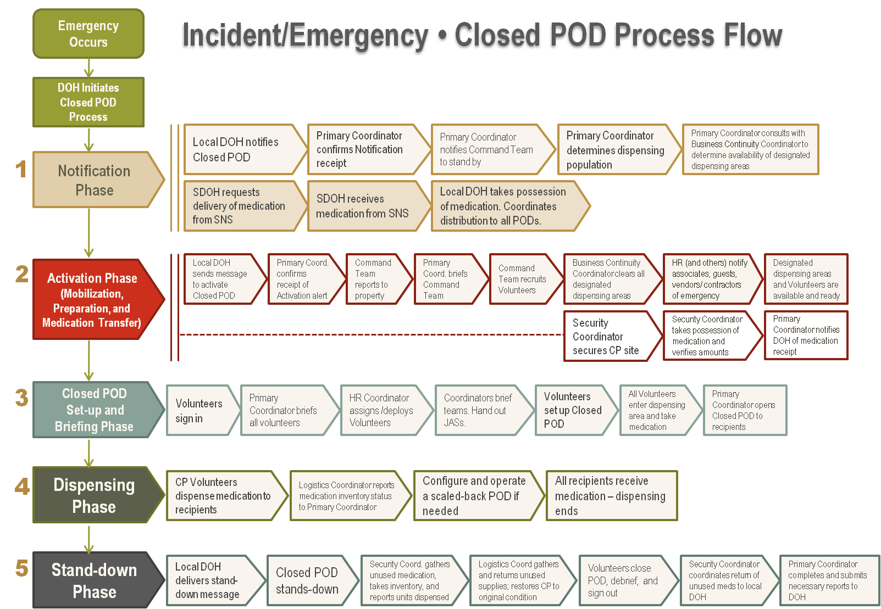

Closed POD Planning Kit Contents
What’s In the Kit • How to Use It

Assembling Your Closed POD Planning Kit
- The Closed POD Kit is used during an emergency. The documents in the Closed POD Operations folder are those that will be needed on the day of the event. Print these documents once your Closed POD Plan is finalized. Keep all of the printed documents in a clearly labeled box, stored in the location specified in your property’s Closed POD Plan.
- All files are in Microsoft Office format, and use standard Windows fonts.

Kit Component | How To Use It | Item Thumbnail
PLANNING TOOLS DOCUMENTS
- Closed POD Definitions  - The Lexicon lists and defines all terms related uniquely to the Closed POD program that are not “household” vocabulary.  - All terms bolded in the Job Action Sheets are defined in the Lexicon.  - All Command Coordinators should become familiar with the terms and definitions described in the Lexicon. | 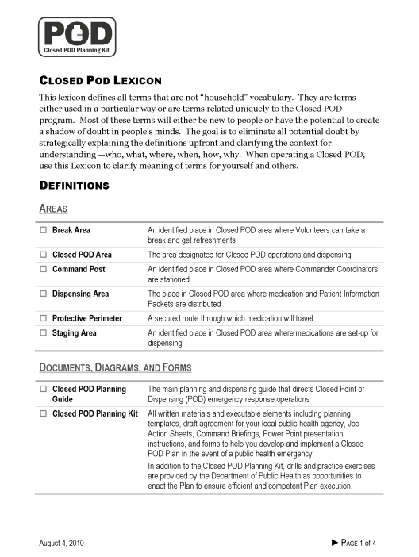
- Closed POD Process Flow Diagram  - A one-page summary diagram showing all main phases and major tasks for operating a Closed POD. | 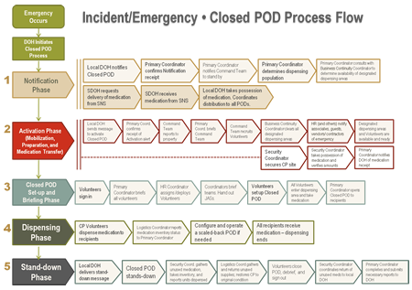
- Department of Health Discussion Guide  - This guide coaches you through approaching and working with your local department of health to plan your Closed POD. | 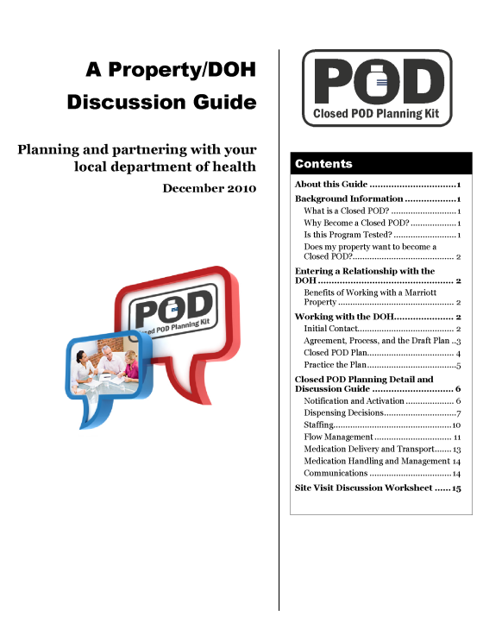
- Site Visit Discussion Worksheet  - This worksheet coaches you through the site visit with your local department of health to plan your Closed POD. | 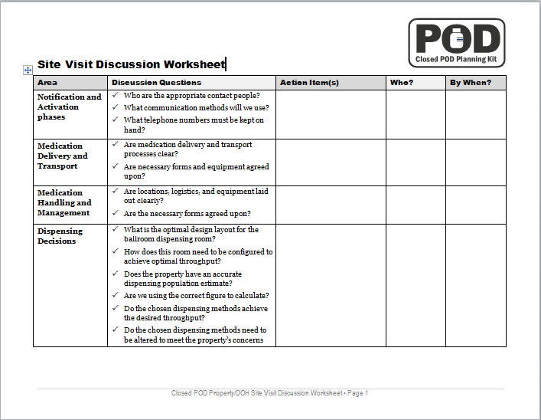
- Closed POD Memorandum of Agreement  - Signed agreement between your property and your local department of health, outlining the roles and responsibilities of each entity when operating a Closed POD.  - All managers should be familiar with the Memorandum and should review the document annually.  Important: This MOA template is an example and the format varies by department of health jurisdiction. Your department of health’s form may not be exactly as illustrated at right. Ensure you obtain the appropriate template prior to completing this form. | 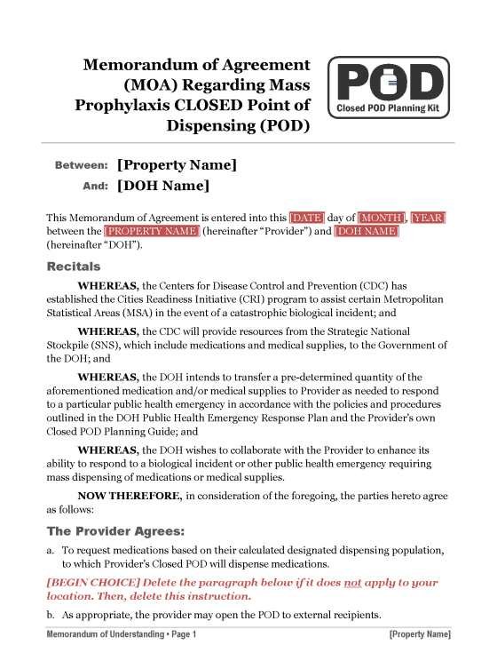
- Dispensing Plan Template  - The template serves as a basis for creating the Closed POD Plan, which is the main planning and dispensing guide that directs Closed Point of Dispensing (POD) emergency response operations, customized for your property.  - Once finalized, and reviewed by your department of health, the planning document becomes the Approved Dispensing Plan.  - All managers should be familiar with the Approved Dispensing Plan and should review the document annually. | 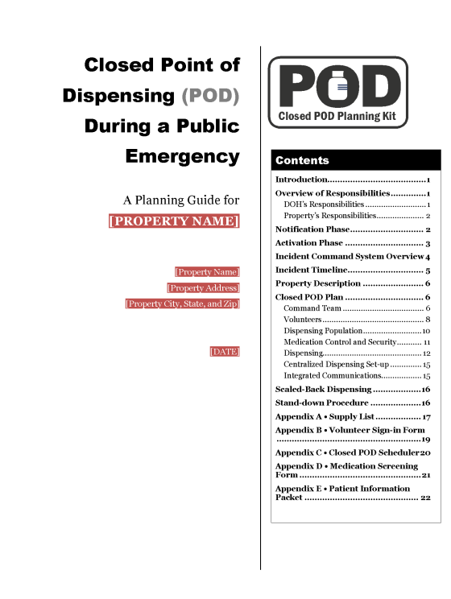
- Associate Orientation  - Include this sheet, or transfer this verbiage into your company’s standard Associate Orientation materials to provide new associates with an overview of Closed POD operations. | 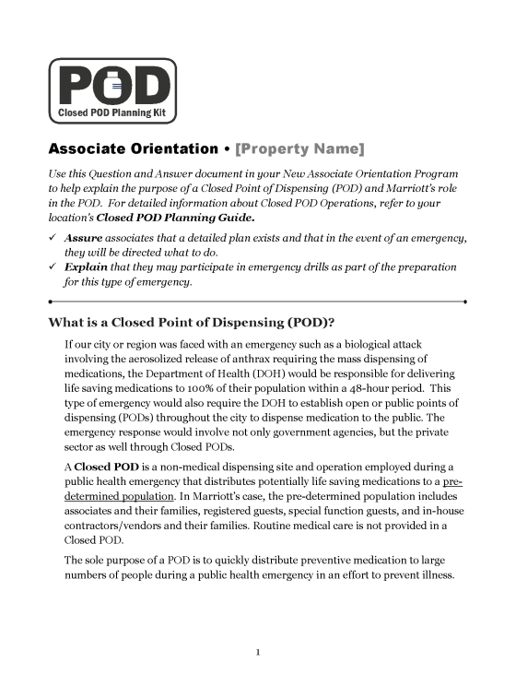
- Manager/Supervisor Training  - Include this sheet, or transfer this verbiage into your company’s standard Manager Training materials to provide new managers with an overview of Closed POD operations. | 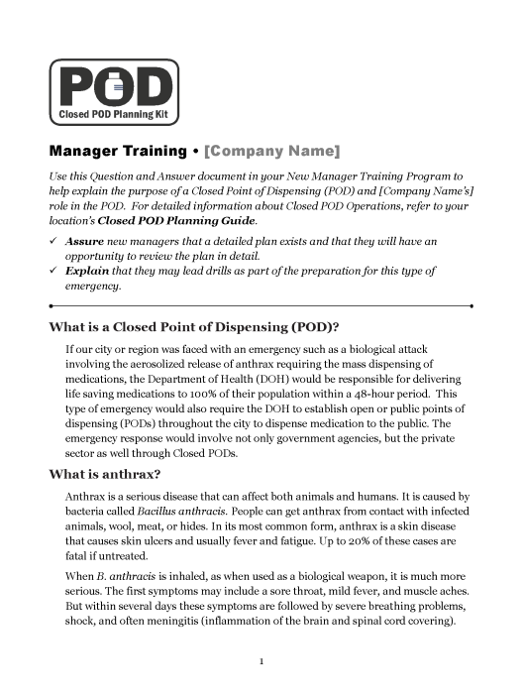
- Signage Guidelines  - Provides a thumbnail view of all signs found in the Closed POD Planning Kit, within the Closed POD Operations/Signage folder. | 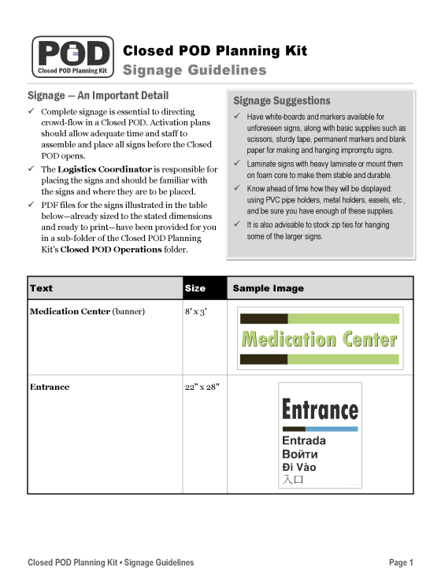

Kit Component | How To Use It | Item Thumbnail
PRACTICE EXERCISES AND DRILLS DOCUMENTS
- Overview PowerPoint Presentation and Facilitator’s Guide  - Tabletop Exercise PowerPoint Presentation and Facilitator’s Guide  - Functional Exercise PowerPoint Presentation and Facilitator’s Guide  - Exercise After Action Report/ Improvement Plan Template | 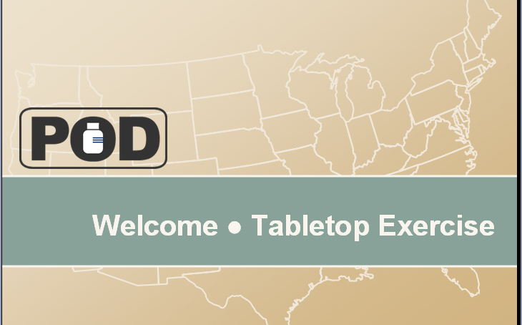

Kit Component | How To Use It | Item Thumbnail
CLOSED POD OPERATIONS DOCUMENTS
- Command Briefing Scripts (6)  - The Command Briefings are used by the Primary Coordinator and the Command Coordinators of each POD area — Security, Logistics, Human Resources, Business Continuity — to brief Volunteers on POD operations.  - The following briefings are included:  - Primary Coordinator to Command Team  - Primary Coordinator to All Volunteers  - Security Coordinator to Security Volunteers  - Logistics Coordinator to Logistics Volunteers  - Human Resources Coordinator to HR Volunteers  - Business Continuity Coordinator to Room Service Volunteers | 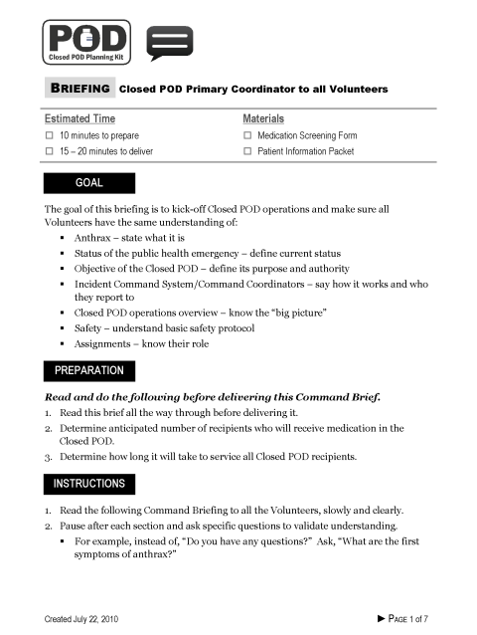
- Job Action Sheets (16)  - Job Action Sheets instruct Volunteers on their Closed POD role and tasks.  - The following Job Action Sheets are included:  - Primary Coordinator  - Security Coordinator  - POD Security  - Queue Control  - Logistics Coordinator  - Runner  - Maintenance  - Food Service Provider  - Human Resources Coordinator  - Greeter  - Screener  - Dispenser  - Exit Monitor  - Business Continuity Coordinator  - Room Service  - Associate Dispensing Coordinator | 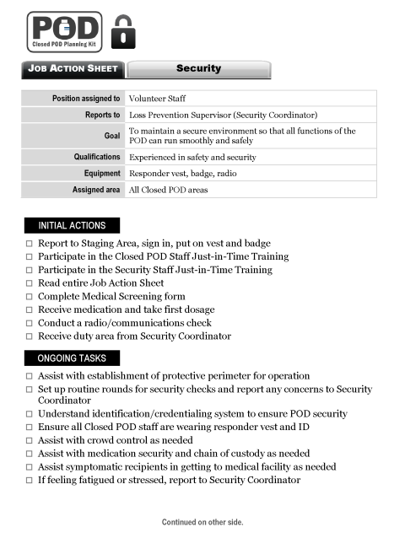  When printed, sort sheets by area as shown in the outline at left.
- Closed POD Sign In / Sign Out Sheet  - Volunteers sign in and out of the POD using this roster.  - Before printing, replace [name] [address] at the top of the first page with your property information. | 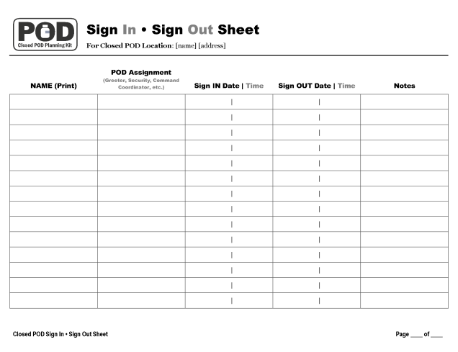
- Scheduler Sheet  - The Command Coordinator of each Closed POD area uses this form to schedule the area’s Volunteers.  - Before printing, replace [name] [address] at the top of the page with your property information.  - On the day of a drill or event:  - Check off the POD AREA and complete (hand write) the COORDINATOR NAME and Date blanks.  - Check off the AM or PM box to indicate when the schedule begins. The grid represents a 12-hour period. Each box represents one hour, and has a mark for the half hour.  - For each Volunteer, write his/her name and role (Greeter, Runner, etc.). Draw a line through the boxes to show the time on duty. | 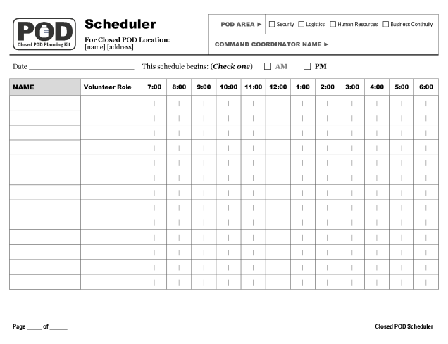
- Medication Screening Form  - Each POD Volunteer and recipient completes this form for his/her household to receive medication.  - The Screener reviews the form and determines which medication each member of the household receives.  - The Dispenser reviews the form for completeness and accuracy and dispenses medication for each household member listed on the form.  - IMPORTANT: The Medication Screening Form varies by department of health jurisdiction. . Your form may not be exactly as illustrated at right. Ensure you obtain the appropriate Medication Screening Form prior to including in your plan. | 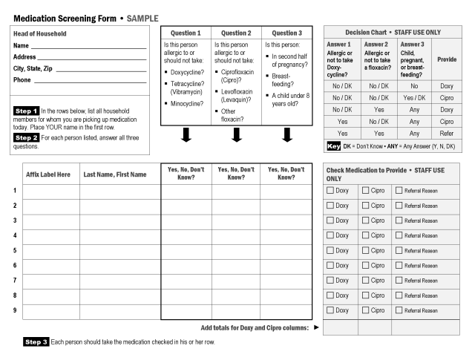
- Medication Screening Form Example/Job Aid  - A sample completed Medication Screening Form with some helpful hints and guidelines on the back.  - Print double-sided to make a convenient single-sheet job aid | 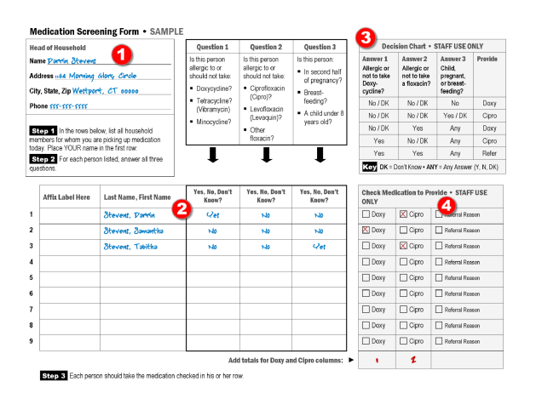
- Greeter’s Script  - The Greeter reads the script aloud to the recipients waiting in the queue.  - The Greeter reads the script at intervals that ensure that all new recipients in line receive the information in the script. | 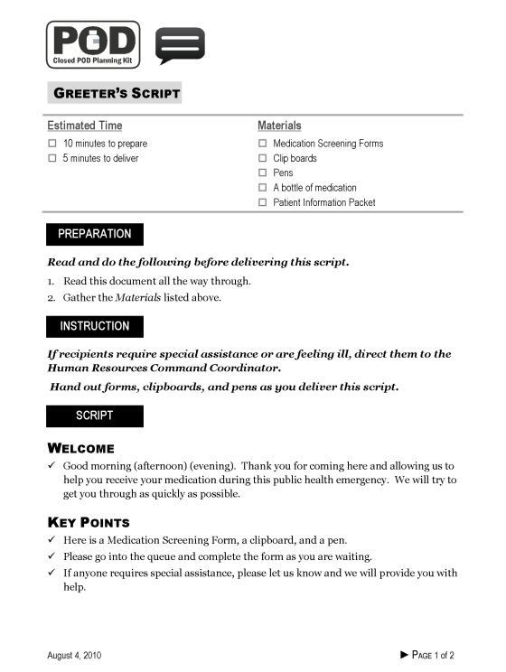
- Public PowerPoint Presentation  - The presentation provides public information about the Closed POD dispensing operations and answers Frequently Asked Questions (FAQs).  - Edit the file to customize it with your property information. Edit the following slides:  - Slides 1 and 8 – Add your location/property name  - Slide 4 – If desired, replace the diagram with your POD map  - Slide 9 – Add your department of health name  - When the Closed POD opens, play the looping presentation on monitors in the greeting/queue area. | 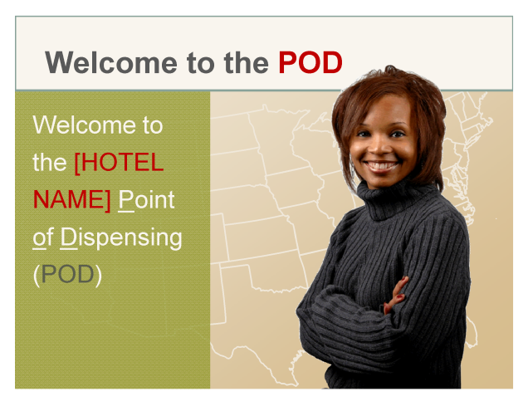

The Memorandum of Agreement (MOA)

How to Complete the Memorandum of Agreement
 | Do this | Illustration • Note(s)
1 | In Microsoft Word, open the file:  03_pod_planning_  moa_template.doc | The Microsoft Word document in the Closed POD Planning Kit is created in Microsoft Word 2002/2003 format and will open in Word 2007/2010 in Compatibility Mode.
2 | Use the File, Save As command to save a copy of the document with the name:  01_closed_pod_moa_  property_name.doc  - Save the copy in the Planning Tools folder for now, and keep it there as you work on it.  - Once the document is finalized, you will move it to the Closed POD Operations folder. | 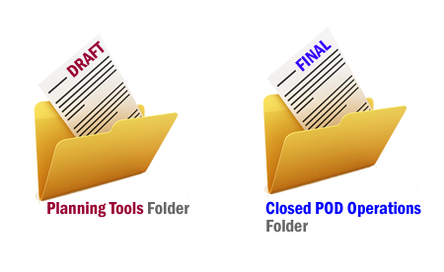
3 | To help with the editing process, set the Show/Hide icon to Show.  - When set to Show, you’ll be able to see the paragraph end marks in your document. | When set to the “Show” position, the icon appears “pushed in.” Here’s where to find the Show/Hide icon:  Word 2002/2003: On the Standard toolbar.  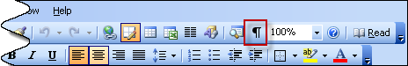  Word 2007/2010: In the Paragraph section on the Home Ribbon.  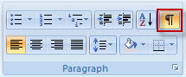
4 | Edit the [Property Name] and [DOH Name] at the top of the document.  - Select the text [Property Name] and type over it with your property name.  - Select the text [DOH Name] and type over it with the name of your local department of health. | 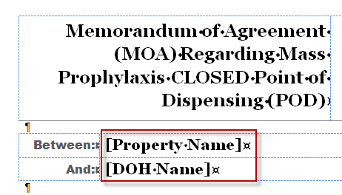
5 | Replace all red-shaded variables in the body of the document with your own information.  - All variable information displays with red shading and white text.  - Use the mouse or cursor keys to highlight each variable block, and type over the selection with your data.  - Save your document frequently as you work. | 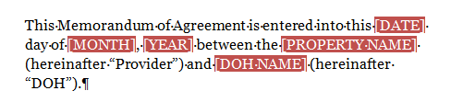  Leave the red shading in place until your document is nearly final. This way, if you need to make further edits to the variable information, you’ll be able to find it easily. Steps 7 and 8 tell you how to easily remove the shading from the entire document in one quick operation.
6 | Address all decision points in the document. These sections are labeled with [BEGIN CHOICE] instructions and [END CHOICE] markers.  - Review the instructions for each decision point.  - Select and delete the information that does not apply to your location. Include the paragraph mark in your selection.  - Delete the [BEGIN CHOICE] and [END CHOICE] paragraphs. Include the paragraph mark in your selection. | 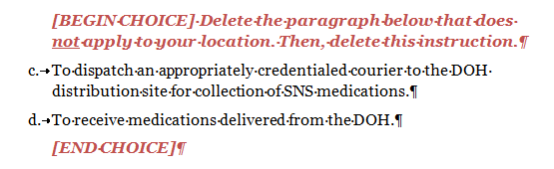  Including the paragraph mark when you select and delete a paragraph helps keep the document format intact. The paragraph mark is like a container that “holds” all of the formatting instructions for the paragraph.
7 | Prepare to remove the red shading from the document.  - Display the Styles Pane. | To display the Styles Pane:  Word 2002/2003: Choose Format, Styles and Formatting from the menu.  Word 2007/2010: Click the small arrow at the bottom right of the Styles Section on the Home Ribbon.  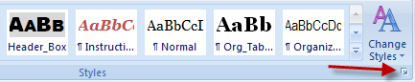
8 | Delete the Variables character style. Doing so removes all red shading from the document.  - In the Styles Pane, locate the Variables style in the list.  - Click the drop-down arrow to the right of the style.  - Click Delete Variables…  - Click Yes when prompted to confirm. | 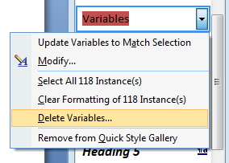  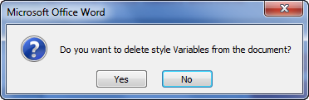
9 | Save the final MOA document.

The Closed POD Plan

How to Complete the Closed POD Plan
The Closed POD Plan document will likely not be completed in one sitting. Much of the information in the Closed POD Plan is the result of decisions made during your early discussions with your local department of health. The Closed POD Plan also includes a list of all Closed POD Coordinators, so these people need to be enrolled and selected before the Closed POD Plan can be finalized.
 | Do this | Illustration • Note(s)
1 | In Microsoft Word, open the following file from the Closed POD Planning Kit’s Planning Tools folder:  03_pod_dispensing_plan  _template.doc | The Microsoft Word document in the Closed POD Planning Kit is created in Microsoft Word 2002/2003 format and will open in Word 2007/2010 in Compatibility Mode.
2 | Use the File, Save As command to save a copy of the document with the name:  02_closed_pod_plan_  property_name.doc  - Save the copy in the Planning Tools folder for now, and keep it there as you work on it.  - Once the document is finalized, you will move it to the Closed POD Operations folder.
3 | To help with the editing process, set the Show/Hide icon to Show.  - When set to Show, you’ll be able to see the paragraph end marks in your document. | When set to the “Show” position, the icon appears “pushed in.” Here’s where to find the Show/Hide icon:  Word 2002/2003: On the Standard toolbar.  Word 2007/2010: In the Paragraph section on the Home Ribbon.
4 | Edit the [Property Name], [Property Address] and other variable information on the cover page.  - Select the text [Property Name] and type over it with your property name.  - Repeat with each bracketed variable. | 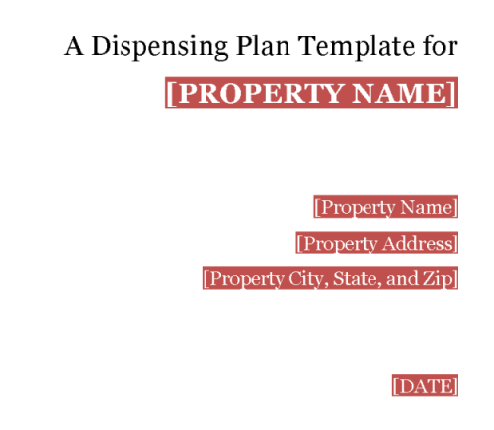
5 | Replace all red-shaded variables in the body of the document with your own information.  - All variable information displays with red shading and white text.  - Use the mouse or cursor keys to highlight each variable block, and type over the selection with your data.  - Save your document frequently as you work. | 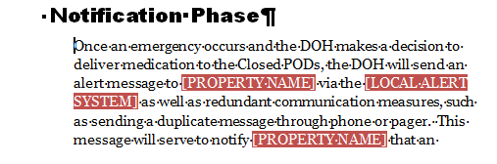  Leave the red shading in place until your document is nearly final. This way, if you need to make further edits to the variable information, you’ll be able to find it easily. Steps 8 and 9 tell you how to easily remove the shading from the entire document in one quick operation.
6 | Address all decision points in the document. These sections are labeled with [BEGIN CHOICE] instructions and [END CHOICE] markers.  - Review the instructions for each decision point.  - Select and delete the information that does not apply to your location. Include the paragraph mark in your selection before deleting.  - Delete the [BEGIN CHOICE] and [END CHOICE] paragraphs. Include the paragraph mark in your selection. | 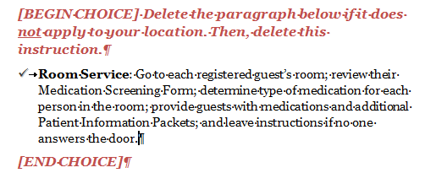  Including the paragraph mark when you select and delete a paragraph helps keep the document format intact. The paragraph mark is like a container that “holds” all of the formatting instructions for the paragraph.
7 | Follow all instructions in the document. Instructions display in red, bolded, italicized text.  - Delete the instructional paragraph(s) when finished. Include the paragraph mark in your selection before deleting. | 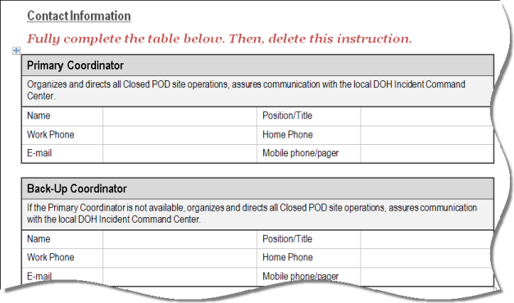
8 | Prepare to remove the red shading from the document.  - Display the Styles Pane. | To display the Styles Pane:  Word 2002/2003: Choose Format, Styles and Formatting from the menu.  Word 2007/2010: Click the small arrow at the bottom right of the Styles Section on the Home Ribbon.
9 | Delete the Variables character style. Doing so removes all red shading from the document.  - In the Styles Pane, locate the Variables style in the list.  - Click the drop-down arrow to the right of the style.  - Click Delete Variables…  - Click Yes when prompted to confirm.
10 | Save the final Closed POD Plan document.

Appendix • Document Index

 |  | Planning Tools
 |  | Item |  |  | File Name
 |  | Instructions and Tools for Closed POD Planning |  |  | 00_pod_planning_instructions.doc
 |  | Closed POD Definitions |  |  | 01_ pod_planning_definitions.doc
 |  | Closed POD Process Flow Diagram |  |  | 01_pod_planning_process_diagram.ppt
 |  | Property/DOH Discussion Guide |  |  | 02_ pod_planning_doh_discussion.doc
 |  | Site Visit Discussion Worksheet |  |  | 02_pod_planning_site_visit_worksheet.doc
 |  | Closed POD Memorandum of Agreement (MOA) Template |  |  | 03_ pod_planning_moa_template.doc
 |  | Dispensing Plan Template |  |  | 04_ pod_dispensing_plan_template.doc
 |  | Associate Orientation (sample) |  |  | 05_ pod_planning_associate_orientation.doc
 |  | Manager Training (sample) |  |  | 05_ pod_planning_manager_training.doc
 |  | Signage Guidelines |  |  | 06_ pod_planning_signage_guide.doc
 |  | Practice Exercises and Drills
 |  | Item |  |  |  | File Name
 |  | Exercise Instructions |  |  |  | 00_closed_pod_exercise_instructions
 |  | Overview Facilitator’s Guide |  |  |  | 01_closed_pod_overview_fg
 |  | Overview Presentation |  |  |  | 02_closed_pod_overview_presentation
 |  | Tabletop Exercise Facilitator’s Guide |  |  |  | 03_closed_pod_tabletop_fg
 |  | Tabletop Exercise Presentation |  |  |  | 04_closed_pod_tabletop_presentation
 |  | Tabletop Exercise Evaluation Form |  |  |  | 05_closed_pod_tabletop_evaluation_form
 |  | Functional Exercise Facilitator’s Guide |  |  |  | 06_closed_pod_functional_fg
 |  | Functional Exercise Presentation |  |  |  | 07_closed_pod_functional_presentation
 |  | Functional Exercise Evaluation Form |  |  |  | 08_closed_pod_tabletop_evaluation_form
 |  | After Action Report/Improvement Plan Template |  |  |  | 09_closed_pod_aar_template
 |  | Closed POD Operations
 |  | Item | File Name
 |  | Place final copy of MOA file in the Closed POD Operations folder, and name it as shown at right. | 01_closed_pod_moa_property_name.doc
 |  | Place final copy of approved dispensing plan file in the Closed POD Operations folder, and name it as shown at right. | 02_closed_pod_plan_property_name.doc
 |  | Command Brief to Command Team | 03_closed_pod_command_briefing_01_  commanders.doc
 |  | Command Brief to Volunteers | 03_closed_pod_command_briefing_02_  volunteers.doc
 |  | Command Brief from Security Coordinator to Team | 03_closed_pod_command_briefing_03_  security.doc
 |  | Command Brief from Logistics Coordinator to Team | 03_closed_pod_command_briefing_04_  logistics.doc
 |  | Command Brief from Human Resources Coordinator to Team | 03_closed_pod_command_briefing_05_  human_resources.doc
 |  | Command Brief from Business Continuity Coordinator to Team | 03_closed_pod_command_briefing_06_  business_continuity.doc
 |  | Job Action Sheet - Primary Coordinator | 04_closed_pod_job_action_sheet_01_  primary-coord.doc
 |  | Job Action Sheet – Security Coordinator | 04_closed_pod_job_action_sheet_02_  security-coord.doc
 |  | Job Action Sheet – Logistics Coordinator | 04_closed_pod_job_action_sheet_03_  logistics-coord.doc
 |  | Job Action Sheet – Human Resources Coordinator | 04_closed_pod_job_action_sheet_04_  hr-coord.doc
 |  | Job Action Sheet – Business Continuity Coordinator | 04_closed_pod_job_action_sheet_05_  business-coord.doc
 |  | Job Action Sheet – Associate Dispensing Coordinator | 04_closed_pod_job_action_sheet_06_  assoc-disp-coord.doc
 |  | Job Action Sheet – Greeter | 04_closed_pod_job_action_sheet_07_greeter.doc
 |  | Job Action Sheet – Screener | 04_closed_pod_job_action_sheet_08_screener.doc
 |  | Job Action Sheet – Dispenser | 04_closed_pod_job_action_sheet_09_  dispenser.doc
 |  | Closed POD Operations
 |  | Job Action Sheet – Exit Monitor | 04_closed_pod_job_action_sheet_10_  exit_monitor.doc
 |  | Job Action Sheet – Security | 04_closed_pod_job_action_sheet_11_security.doc
 |  | Job Action Sheet – Maintenance | 04_closed_pod_job_action_sheet_12_  maintenance.doc
 |  | Job Action Sheet – Food Service Provider | 04_closed_pod_job_action_sheet_13_  food_service.doc
 |  | Job Action Sheet – Runner | 04_closed_pod_job_action_sheet_14_runner.doc
 |  | Job Action Sheet – Queue Control | 04_closed_pod_job_action_sheet_15_  queue_control.doc
 |  | Job Action Sheet – Room Service | 04_closed_pod_job_action_sheet_16_  room_service.doc
 |  | Form – Medication Screening Form, Cipro/Doxy | 05_closed_pod_form_medication_screen_  cipro_doxy.doc
 |  | Form – Medication Screening Form Job Aid | 05_closed_pod_form_medication_screen_  job_aid.doc
 |  | Form – Closed POD Scheduler | 05_closed_pod_form_scheduler.doc
 |  | Form – Volunteer Sign In Form | 05_closed_pod_form_sign-in_sheet.doc
 |  | Greeter’s Script | 06_closed_pod_greeters_script.doc
 |  | Day of Event Communication Matrix with Sample Messaging | 07_closed_pod_communications.doc
 |  | Public PowerPoint Presentation | 08_closed_pod_public_powerpoint.ppt
 |  | Signage |  | File names within the Signage folder are self-explanatory. Refer to the Signage Guidelines document for thumbnail images of all signs included in this folder.

