 |  | Closed Point of  Dispensing (POD)  Tabletop Exercise  Closed POD Plan, Roles  and Process Flow  June 23, 2011
  Facilitator’s Guide

Contents
Instructor Preparation i
About the Tabletop Exercise i
Prepare to Facilitate i
How to Use this Facilitator Guide iv
Course Materials vi
Instructor Materials List vi
Participant Materials vi
Introduction 1
Welcome, Introductions, and Goal 1
What is a Tabletop? 1
Tabletop Guidelines 2
Today’s Agenda 2
Tabletop Goal 3
Closed POD Process Overview 3
What would happen if…? 4
Phase 1 • Notification 5
Notification Alert Response 5
Scenario Continues 6
Phase 2 • Activation 7
Activation Alert Response 7
The Event Unfolds 9
Phase 3 • Closed POD Set-up and Briefing 10
POD Set-up and Briefing 10
The Event Continues 12
Phase 4 ● Dispensing 13
Dispensing 13
The Event Winds Down 15
Phase 5 ● Stand-down 16
Stand-down 16
Evaluation 17
Next Steps 17
Appendix ● Next Steps Worksheet 18

Instructor Preparation

About the Tabletop Exercise
Once the local Department of Heath (DOH) has approved your property’s Closed POD Plan, and you have shared your property’s final plan with your Command Team, you are ready to schedule the Tabletop exercise. Use this guide to facilitate the Tabletop exercise with your Command Team.

Session Goal
Use the Tabletop exercise to collectively “work the plan” and to gain team confidence so that when your local Department of Health (DOH) schedules a Functional exercise, your Closed POD team will be ready to practice executing the Closed POD Plan with the DOH.
The goal of the Tabletop exercise is three fold:
- To demonstrate viability of the Closed POD Plan.
- To use the results to update and improve the plan.
- To educate the responsible parties on their roles and tasks carrying out the plan.

Prepare to Facilitate

Session Materials
Before you deliver this Tabletop exercise, make sure you have completed the following:
- Know the Closed POD Plan. To be able to create dynamic discussion and validate understanding, know your property’s Closed POD Plan and its detail.
- Know the Planning Kit. Make sure you are very familiar with all the documents in the Closed POD Planning Kit and how it is organized.
- Read this Guide. Read this Guide all the way through to familiarize yourself with the line of questioning. Know where you want to dig deeper to uncover potential risks or holes in the plan.
- Invite the DOH to attend. Invite your local emergency preparedness partners to attend this exercise. If the DOH declines to participate, provide them with an After Action Report so they are aware of your property’s progress.
- Schedule the exercise. Allow four uninterrupted hours to go step by step through the plan, discuss, evaluate and determine next steps. If multiple hotel teams attend the exercise, allow for more time.
- Tell the Command Team how to prepare. When scheduling the exercise, state specifically how you want people to prepare for the session. Based on pilot program experience, we recommend that the Command Team has read the property’s Closed POD Plan, has attended the Overview Meeting, knows their role and responsibilities, and is familiar with the Closed POD Planning Kit.
- If you have previously provided hand outs from the Closed POD Planning Kit, request that participants bring these hand outs to the Tabletop session.
- Assign a scribe. Prior to the exercise, decide who will be the principal note-taker. It is important to document key discoveries and unearthed concerns, risks, unintended consequences, etc. that require follow up and/or to be written into your property’s Closed POD Plan.

Facilitation Suggestions
This session is designed to be facilitated by the Closed POD Primary Coordinator. Alternatively, if necessary, the Back-up Coordinator can deliver this session.
- Review this entire guide and add your own notes as you see fit.
- Use your own knowledge and expertise from the planning process to elaborate on facilitation points and ensure understanding.
- Use a “parking lot” during the discussion. Answers to all questions that arise throughout the discussion may not be immediately evident; place unknowns in the “parking lot” to tackle later. You may want to consult a community partner such as the local police. Flip chart all unanswerable questions and research answers.
- Follow up after the exercise. Make sure to adapt the property’s Closed POD Plan and communicate any updates to your Command Team and the DOH.

Room Preparation
Some preparation pointers:
- It may be helpful for everyone to have a nametag that shows not only their name but their Closed POD role.
- Choose a comfortable room with good sightlines for all participants to be able to view the PowerPoint presentation.
- Use a white board or flipchart for group documentation (such as the “parking lot”).
- You may wish to have page flags and highlighter markers available to mark those sections of the plan that will require updating based on the exercise results.
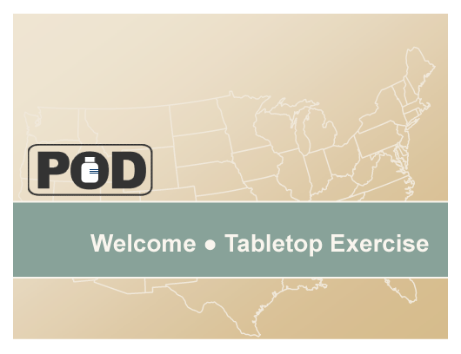  Slide [Number]   | How to Use this Facilitator Guide  This guide contains suggested scripting, which appears in a plain Roman font. The scripting helps guide you through the main points and provides the introductions and transitions needed to link the subjects together.  - Directives are not meant to be said aloud. They provide direction to you, the facilitator.  Directives are formatted like this, in bold italics.  - Thumbnail slide images are shown in the left column when it’s time to display a new slide. The slide number is included. (See the example at left.)  - Some slides require multiple clicks to play a simple animation. Slides requiring multiple clicks display the number of clicks at the top right of the screen, in a small mouse icon (shown at left).
- In the Q&A session sections, answers to the prompting questions are provided in this guide.
- Answers are formatted like this, with a checkbox bullet.
- Certain answers are property-dependent. Consult your property’s Closed POD Plan for these answers.
- Answers that require you to consult your property’s Closed POD Plan or require a solution unique to your property are formatted with a box with no checkmark and an Arial Narrow font.
Question & Answer  Handout/Worksheet | Icons  A couple of icons are used to help identify certain types of content (see icons at left):  - A Q&A icon flags a discussion section.  - A pencil and paper icon displays when it’s time to distribute a participant worksheet or other handout.

Course Materials

Instructor Materials List
In addition to this Facilitator’s Guide, you’ll need the following materials:
- Closed POD Tabletop presentation
- Your property’s Closed POD Plan
- Participant hand outs (below)

Participant Materials
Have enough copies available for participants’ reference.
- Closed POD Kit, Planning Tools documents:
- Approved Closed POD Plan
- POD Definitions
- POD Process Diagram
- Closed POD Kit, Closed POD Operations documents:
- Closed POD Job Action Sheets
- Closed POD Command Briefings
- Closed POD Communications Matrix
- Medication Screening Form

Introduction
Slide 1 | Welcome, Introductions, and Goal  Welcome participants to the session. If introductions are appropriate, make them now.  Deliver a few opening remarks.  - If you are in this room, you are an important part of our property’s Closed POD Plan.  - As a Command Coordinator and part of the Closed POD Command Team, you have a crucial role to play in the Closed POD.  - I hope you’ve had a chance to familiarize yourself with the Closed POD Plan.  - Today’s exercise will help you gain more confidence understanding the plan and your role in the plan.
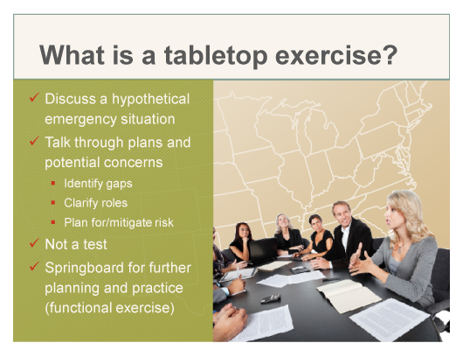  Slide 2 | What is a Tabletop?  Explain the Tabletop exercise. Be prepared to mention when your property will perform the Functional exercise.  A tabletop exercise:  - Presents a hypothetical emergency situation so that the group can discuss plans as seen through the lens of a potential real life situation.  - It is an opportunity to talk through plans and potential concerns, specifically to identify gaps in the plan, clarify roles – your role and others’, and create plans for any potential risk or concern.  - It is not a measure of individual performance. It’s not a test, but a group exercise.  - It’s a springboard for further planning and practice, specifically the practice exercises with the DOH.
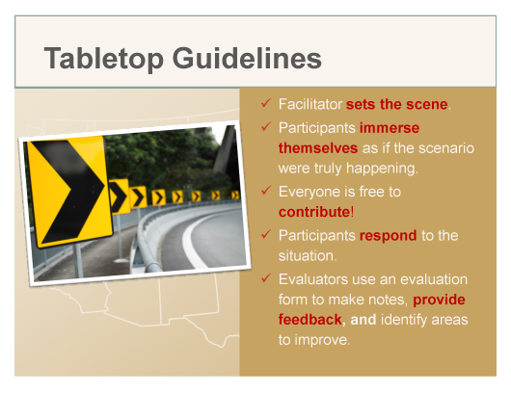  Slide 3 | Tabletop Guidelines  Review the Tabletop guidelines. Encourage all to participate. State that silence means agreement, so motivate people with any hesitation or doubt to speak up.  - The purpose of this exercise is to “poke holes” in our plan.  - If you have a doubt or hesitation that may indicate that something in the plan is not clear. We want to unearth what is not clear or fully thought-out.  - Use your creative imagination and put yourself in the emergency situation as we go step by step through this plan. Visualize the sights, sounds, places, etc. to help “bring alive” the plan.  - Our evaluator(s) are here not to judge anyone’s performance, but to give us feedback that will allow us to improve our plan. This is our goal – to find potential gaps and fix them prior to an emergency situation.
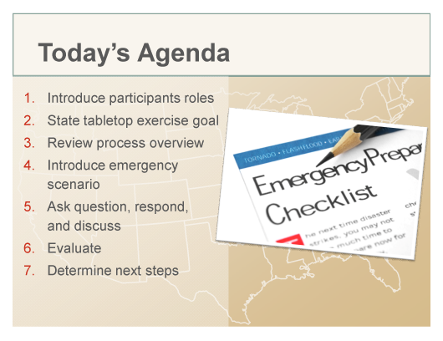  Slide 4 | Today’s Agenda  Review the agenda and mention any housekeeping details such as breaks, bathrooms, etc.  Make sure that everyone in the room knows who is responsible for each POD role, such as Back-up Coordinator, Security Coordinator, etc.  - This session is scheduled to take about four hours (more if there is more than one property in attendance).  - We will walk through the plan step by step.  - I’ll prompt you with questions. Your job is to find the answers and ask as many questions as you see fit so that we as a team, develop a collective working understanding of this plan.  - If you don’t have an immediate answer, use the available documents to find the answer.  - At the end of the session, we’ll go through the evaluation, and plan next steps.
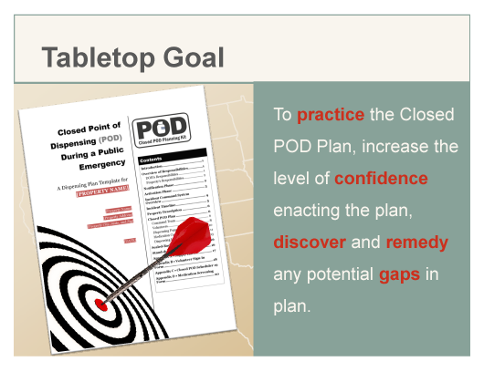  Slide 5 | Tabletop Goal  Read the goal. Ask if anyone has questions or anything to add.
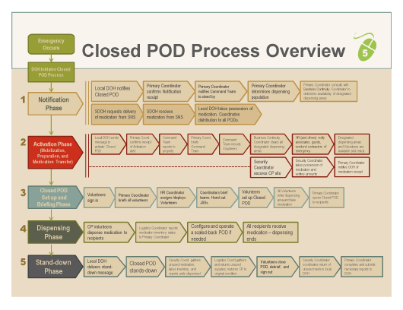  Slide 6 | Closed POD Process Overview  Note that this process is also shown on a hand out (for better readability) – Closed POD Process Diagram.  Review the Closed POD Process Overview. Highlight the following points:  - We’ll discuss this process in phases.  - Given an emergency, the entire process begins when the DOH gives the signal to initiate Closed and Open PODs.  - The first phase is the Notification phase. Our property follows the process shown on the top row, while the medication follows the path shown on the bottom row.  - In the second phase, Activation, you can see in the bottom row, the medication is still moving. This is the “readiness” phase when our property is mobilizing to execute.  - The third phase allows us to set up dispensing areas, prepare the Volunteers, and provide team briefings.  - Dispensing is the fourth phase where we give out lifesaving medication to our targeted dispensing population.  - Lastly, the fifth phase is where we break down the POD and resume normal operations.

Transition
With that “big-picture” overview of the POD process, let’s dive into a real life potential scenario that will help us examine our plan.
  Slides 7… | What would happen if…?  Set the stage by creating a “real life” scenario with the slide imagery. The slide produces a sound to create dramatic effect. Use your voice to build on this “drama” and to convey tension that helps participants imagine that an emergency situation is at hand.
…through 12  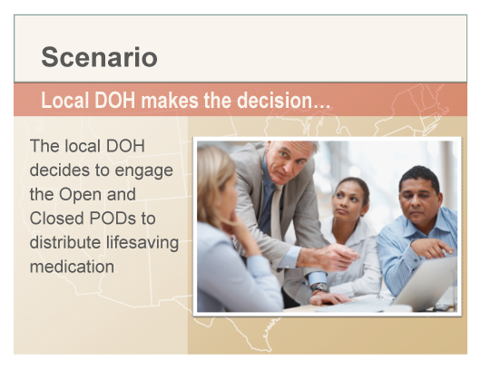 | Transition  Let’s begin our discussion at the beginning of the Notification phase.

Phase 1 • Notification
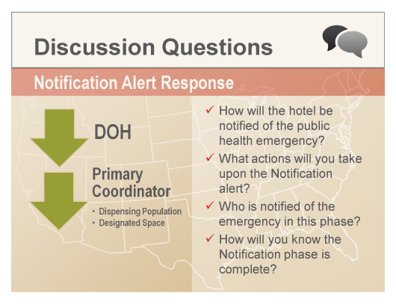  Slide 13  Q&A | Notification Alert Response  Create a discussion using the prompting questions on the slide.  - How will the hotel be notified of the public health emergency?  - By an alert message sent from the local DOH through the local alert network system, as well as a redundant communication  - What actions will you take upon the Notification alert?  - The Primary Coordinator confirms receipt of the alert message.  - The Primary Coordinator determines the actual dispensing population and gets this number to the DOH.  - Who is notified of the emergency in this phase?  - The Primary Coordinator contacts the Command Team to monitor their communication devices and stand by.  - How will you know the Notification phase is complete?  - The Primary and Business Continuity Coordinators have consulted to determine available space for the dispensing areas.

Additional Questions
Use the questions below to “dig deeper” into the plan details.
- What is the expected timeframe in which the DOH is expected to activate the property?
- See the property’s Closed POD Plan.

Transition
Let’s take a look at the continuing scenario.
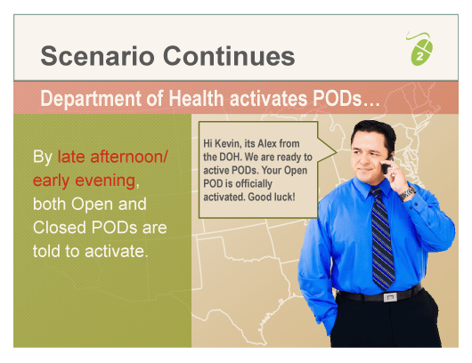  Slide 14 | Scenario Continues  Continue the story using tone to simulate an emergency situation.

Phase 2 • Activation
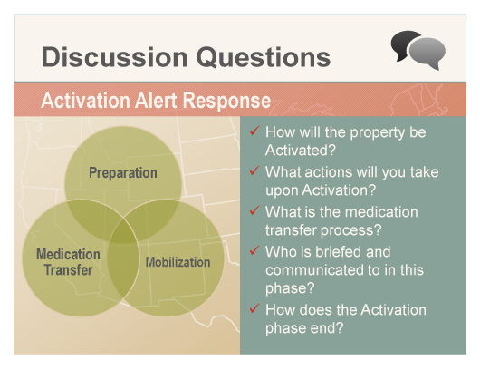  Slide 14  Q&A | Activation Alert Response  Create a discussion using the prompting questions on the slide.  - How will the property be activated?  - The DOH will send a second alert message to hotel via the local alert system as well as redundant communication measures.  - What actions will you take upon Activation?  - The Primary Coordinator confirms receipt of the alert.  - Command Team reports to the property.  - Primary Coordinator briefs the Command Team.  - The Command Team recruits Volunteers.  - The Business Continuity Coordinator clears all dispensing areas.  - The dispensing population is notified.  - Readiness is established.
- What is the medication transfer process?
- Security Coordinator secures the site.
- Upon arrival, the Security Coordinator takes possession of the medication.
- The Primary Coordinator notifies the DOH of receipt.
- For method (pick up or delivery) and specifics, see the property’s Closed POD Plan.
- Who is briefed and communicated to in this phase?
- Associates, guests, and vendors/contractors are notified differently according to the property’s Closed POD Plan.
- See Communication Matrix for additional communication points.
- How does the Activation phase end?
- It ends when medication arrives and dispensing areas and Volunteers are ready.

Additional Questions
Use the questions below to prompt discussion regarding plan details. Begin questioning by clarifying roles. See your property’s Closed POD Plan for specific answers.
- What is the communication method for receiving and responding to the alert?
- Who is the contact person at the DOH?
- What happens if the phone lines are down or the hotel cannot reach the DOH?
- Will you pick up or receive medications?
- Where is the medication received and stored until the POD is ready?
- What is the plan for medication transport within our property?
- If picking up medication, what identification will you need?
- If receiving medication, what form will you use?
- Who takes the first medication inventory?
- Who will notify associates? How will you notify them?
- Who will notify registered and special function guests? How will you notify them?
- What is your plan to relocate special function guests?
- Who will notify in-house vendors/contractors? How will you notify them?
- What happens if a room is unavailable?

Transition
Let’s look again at the event as it unfolds.
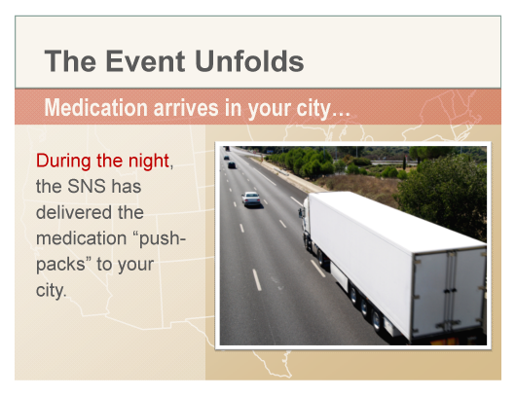  Slides 16…  …through 18  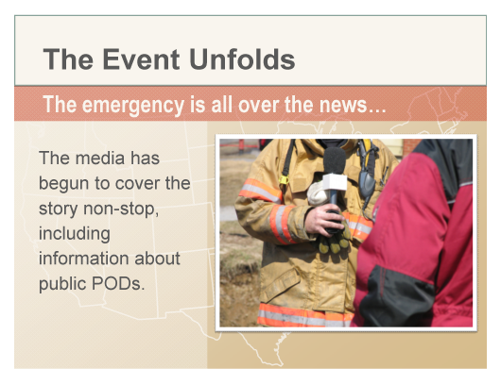 | The Event Unfolds  Continue the story.

Phase 3 • Closed POD Set-up and Briefing
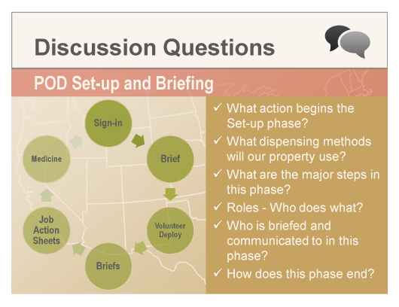  Slide 19  Q&A | POD Set-up and Briefing  Create a discussion using the prompting questions on the slide.  - What action begins the Set-up phase?  - Volunteer sign-in  - What dispensing methods will our property use?  - Consult your property’s Closed POD Plan.  - What are the major steps in this phase?  - Volunteers sign in.  - Primary Coordinator briefs all volunteers.  - HR Coordinator assigns/deploys Volunteers.  - Coordinators brief teams and hand out the Job Action Sheets.  - Volunteers set up dispensing areas.  - Volunteers take their medication.  - Primary Coordinator opens POD to recipients.
- Roles - Who does what?
- See property’s Closed POD Plan to discuss roles, shared roles, and reporting structure.
- Who is briefed and communicated to in this phase?
- Primary Coordinator briefs all volunteers.
- The HR Coordinator signals the Primary Coordinator that all Volunteers are assigned and prepared to be deployed.
- Command Team briefs their teams.
- Command Coordinators let the Primary Coordinator know that their teams have been briefed.
- How does this phase end?
  - Primary Coordinator opens POD to recipients.

Additional Questions
Use the questions below to prompt discussion regarding plan details. Begin questioning by clarifying roles. See your property’s Closed POD Plan and/or Planning Kit for specific answers.
- How many briefings are there?
- What is the purpose of the briefing?
- Describe the briefing sequence.
- What information is included in three stages of briefings?
- Who will set up what area?
- Who reports to whom?
- What supplies will you need? Where are they located?
- What signage is needed? Where will you get it?
- Describe the design layout for the Ballroom dispensing method.
- How will the ballroom be set up? Describe.
- What other dispensing areas must be set up? How will they be set up?
- What happens if a room is not available?
- Who do the Screeners and Dispensers in different locations report to?
- What happens if we don’t have enough Volunteers to open?
- Can Volunteer roles be combined?

Transition
Good discussion so far. Let’s go back to the emergency and see how it is progressing.
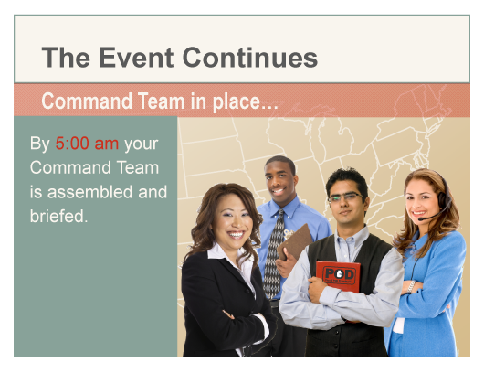  Slides 20…  …through 23  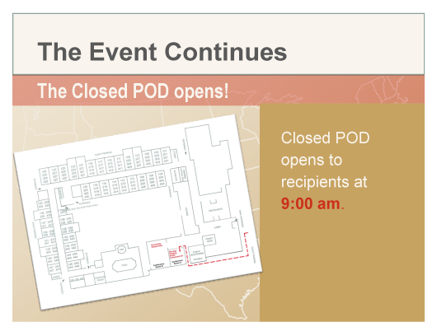 | The Event Continues  Continue the story in a theatrical voice.

Phase 4 ● Dispensing
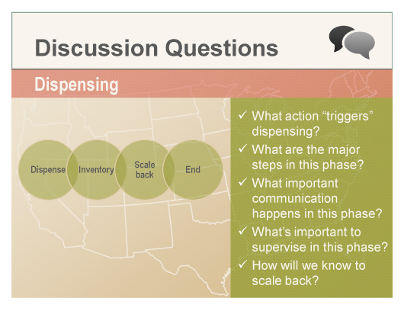  Slide 24  Q&A | Dispensing  Create a discussion using the prompting questions on the slide.  - What action “triggers” dispensing?  - The first recipient  - What are the major steps in this phase?  - Volunteers dispense medication.  - Logistics Coordinator reports inventory status.  - Configure and scale-back (if necessary).  - Dispensing ends.  - What important communication happens in this phase?  - See the Communication Matrix for key communication signals.
- What’s important to supervise in this phase?
- Medication Screening Forms are completed accurately.
- For example, recipients do not request medication for pets.
- Children under 8 years old are acknowledged on the form. For example, if you see 10 people on the form and none of them are marked as children, perhaps there is a mistake.
- Medication is dispensed accurately.
- Associate and Manager Pick-up dispensing operates without bottlenecks or long queues.
- Medication inventory status is tracked and reported.
- Volunteers do not leave their stations. Runners carry messages. Coordinators are stationed in the Command Center.
- Messages/communication follows an Incident Command System protocol – through the direct supervisor.
- How will we know to scale back?
- See your property’s Closed POD Plan
- Note that scale-back and stand-down are different.

Additional Questions
Use the questions below to prompt discussion regarding plan details. Begin questioning by clarifying roles. See your property’s Closed POD Plan for specific answers.
- What are your responsibilities?
- What are your team’s responsibilities and tasks?
- Who handles disgruntled guests?
- Who handles sick or disruptive recipients?
- What happens if a recipient does not speak English?
- How will the property handle walk-ins?
- What if there are security issues beyond what our security is trained to handle?
Medication Screening Form | If time allows, pass out forms and ask the group to complete a Medication Screening Form.

Transition
We’re almost there. Let’s check back in with the emergency event and begin to wind down.
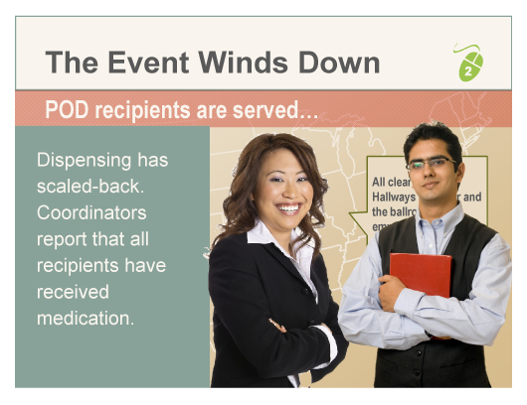  Slides 25…  …through 27  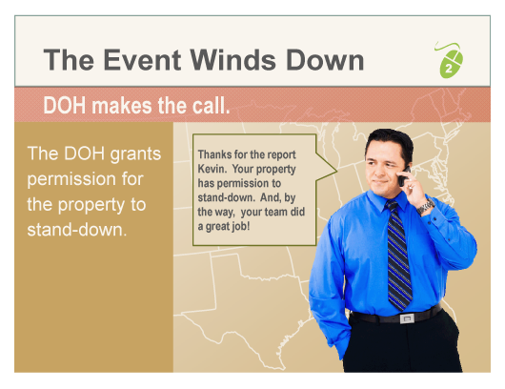 | The Event Winds Down  Bring the story to its conclusion.

Phase 5 ● Stand-down
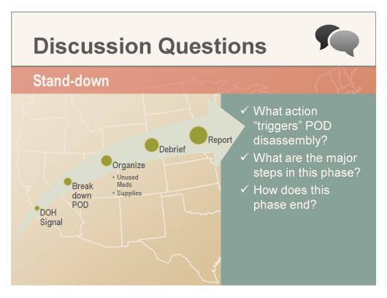  Slide 27  Q&A | Stand-down  Create a discussion using the prompting questions on the slide.  - What action “triggers” POD disassembly?  - The Primary Coordinator requests permission from the DOH. The DOH delivers a message to stand-down.  - What are the major steps in this phase?  - Disassemble the POD.  - Gather unused medication and take inventory.  - Return supplies to storage and restore rooms to their original condition.  - Sign-out and debrief.  - Return unused medication.  - Write and send an After Action Report (AAR) to the DOH.  - How does this phase end?  - When the Primary Coordinator sends the AAR to the DOH.

Additional Questions
Use the questions below to prompt discussion regarding plan details. Begin questioning by clarifying roles. See your property’s Closed POD Plan for specific answers.
- What information will you include in the end debrief?
- Who will update the Closed POD Plan?

Transition
We’ve covered a lot of ground and you’ve all done a great job thus far. Let’s now give a couple moments to our evaluators to gather their thoughts. While they are doing that, we’ll hear your feedback. When the evaluators are ready, they will present their findings.
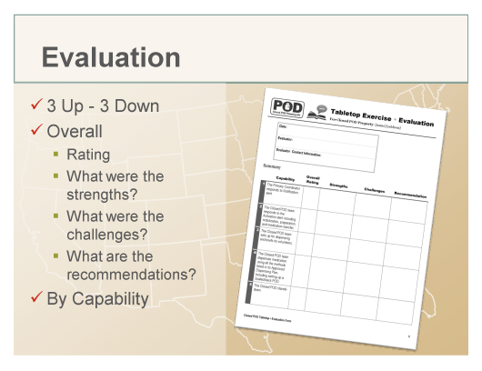  Slide 29 | Evaluation  Ask the participants to give a “three up and three down” – three things that went well and three things that need improvement.  Allow the evaluators a few moments to gather their thoughts and complete their forms. When they are ready, ask them to come forward and present their findings – both overall and in each capacity area.  - Rating  - Strengths  - Challenges  - Recommendations
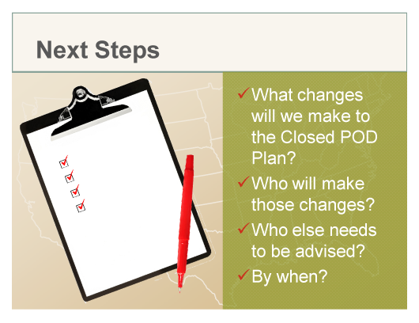  Slide 30 | Next Steps  With the group, determine next steps. Be clear about who will do what and by what date. Use the form in this guide’s Appendix to document To Dos.  Make sure to provide the DOH with any changes to your property’s Closed POD Plan.

Appendix ● Next Steps Worksheet
Action Item | Closed POD Plan Area (page #, section, etc.) | Who? | By When?

