Closed Point of
Dispensing (POD)
During a Public
Emergency

A Dispensing Plan Template for
[Property Name]

[Property Name]
[Property Address]
[Property City, State, Zip]

[Date]

Contents
Introduction 1
Overview of Responsibilities 1
DOH’s Responsibilities 1
Property’s Responsibilities 2
Notification Phase 2
Activation Phase 3
Incident Command System Overview 4
Incident Timeline 5
Property Description 6
Closed POD Plan 6
Command Team 6
Volunteers 8
Dispensing Population 10
Medication Control and Security 11
Dispensing Location and Design 13
Scaled-Back Dispensing 16
Stand-down Procedure 16
Appendix A • Supply List 17
Appendix B • Volunteer Sign-in Form 18
Appendix C • Closed POD Scheduler 19
Appendix D • Medication Screening Form 20

Introduction
In the event of a large-scale public health emergency, the [LOCAL DOH NAME] Department of Health (hereinafter DOH) is charged with developing strategies to deliver lifesaving medications to 100% of its dispensing population within a 48-hour period. If our region was faced with an emergency, such as a biological attack involving the aerosolized release of anthrax requiring a mass dispensing of medications, the response would involve not only government agencies, but the private sector as well. This type of emergency would also require the DOH to establish points of dispensing (PODs) throughout the city to dispense medication to the public.
The [Corporate Name] has a strong culture of corporate responsibility and safety. Consequently, [Property Name] would be a strong partner in the effort to expeditiously provide medication to its local targeted dispensing population through a Closed Point of Dispensing (POD) model. This population includes:
- Associates and their families
- Registered guests
- Special function guests
- In-house vendors/contractors and their families
By partnering with public health and operating a Closed POD, [Property Name]’s local targeted dispensing population will receive medications at the property, reducing the likelihood and the need for this population to visit a public POD. Taking this “extra step” to conduct the necessary coordination and planning, prior to an emergency, while providing a convenient and accessible Closed POD during an anthrax emergency, will provide recipients peace of mind.
Operating a Closed POD will ultimately support continuity of operations plans by contributing to organizational resilience during and after an emergency. Associates will be able to return to their daily duties more quickly, or continue to assist public health officials through volunteering.
Closed PODs provide:
- Ease of access to lifesaving medications
- Quick dispensing of medications to the targeted dispensing population
- Enhanced continuity of operations

Overview of Responsibilities
In the Closed POD partnership between the DOH and the [Property Name], there will be clearly defined roles and responsibilities.

DOH’s Responsibilities
- Provide pre-event planning and technical assistance, including but not limited to policies, procedures, job aids such as sample ballroom dispensing area layouts, fact sheets, dispensing formulas, forms, and other information necessary to successfully operate a Closed POD.
- Provide Closed POD training/education/exercise opportunities to [Property Name] POD volunteers.
- Provide medication and forms during a declared emergency.
- As needed, provide [Property Name] with technical assistance and oversight (via email, telephone, website) to effectively run a Closed POD during a public health emergency and at initial training.
- Declare the Activation phase of a Closed POD plan and notify [Property Name]’s Primary Coordinator (see page 7) to activate the Closed POD.
- If delivering medications, notify [Property Name]’s Primary Coordinator (see page 7) of the expected delivery time and confirm drop off location.
- During the public health emergency, provide media guidance to ensure consistency of messages between the [Property Name]’s targeted dispensing population and the general public.
- After the dispensing process has been completed and the Closed POD deactivated, collect all unused medications and completed medical documentation.
- Include [Property Name] in the conduct of periodic tests of the [LOCAL ALERT SYSTEM].

Property’s Responsibilities
[Property Name] will take the following steps to ensure the proper plans are in place to establish and operate a Closed POD efficiently.
- Designate POD volunteers to work with the DOH and plan for Closed POD operations.
- Provide primary and secondary 24-hour emergency points of contact to ensure timely Closed POD Notification and Activation alerts during a public health emergency.
- Develop a property specific Closed POD Plan. At least once per year, submit to the DOH a copy of the completed Closed POD Plan, including any updates.
- Identify Closed POD dispensing locations.
- Identify Closed POD dispensing methods (Ballroom, Room Service, Associate Pick-up, Manager Pick-Up)
- Maintain the necessary supplies and equipment to operate a Closed POD.
- Use DOH guidance and protocol to dispense medications.
- Participate in DOH predetermined and agreed upon training, exercises, and drills.
- Both primary and secondary emergency points of contacts participate in periodic testing of the [LOCAL ALERT SYSTEM].

Notification Phase
Once an emergency occurs and the DOH makes a decision to deliver medication to the Closed PODs, the DOH will send an alert message to [Property Name] via the [LOCAL ALERT SYSTEM] as well as redundant communication measures, such as sending a duplicate message through phone or pager. This message will serve to notify [Property Name] that an emergency event has occurred. Notification will advise the Closed POD to:
- Contact their designated Command Team to monitor their communication devices and stand by
- Confirm receipt of the message
- Activate the Closed POD within the timeframe coordinated with DOH. [Property Name] will use [TIME FRAME] as its planning benchmark.
The Primary Coordinator will confirm receipt of the alert message. The receipt of confirmation will contain [Property Name]’s intent to supply medication and the actual number of medication regimens required to meet their targeted dispensing population.

Activation Phase
When the DOH decides to activate the [Property Name] ’s Closed POD, the DOH will send a second alert message to [Property Name] via the [LOCAL ALERT SYSTEM] as well as redundant communication measures. This message will notify [Property Name] to:
- Mobilize their Command Team and POD Volunteers and prepare their on-site dispensing areas
- Implement just-in-time training
- Respond with a confirmation of the Activation alert
- Communicate with the 24-hour DOH emergency contact regarding any issues that arise
- Accept DOH’s timeline for POD set-up
Once the DOH receives confirmation that the property has received notice of Activation, they will send a supplemental fax or email with additional instructions. These instructions will contain pertinent information with regards to the transfer of medication. If the property is picking up the medication, time and location will be provided for the pick up. If the medication is being delivered, a timeframe will be provided on when to expect the medication.
If [Property Name] has not been contacted by someone from the DOH within four hours of the declared emergency through the above defined Notification process, the Primary Coordinator should call the DOH at [TELEPHONE NUMBER] for additional information.

Incident Command System Overview
The [Property Name], as a Closed POD, will be incorporated into the DOH’s Incident Command System’s Operations Section of the public health response.
Incident Commander (Local DOH)
Has overall responsibility for the incident
and sets objectives
▼
Operations Branch (Local DOH)
Develops the tactical organization and directs all resources to carry out the Incident Action Plan
▼
SNS Branch (Local DOH)
Coordinates the receipt and distribution of SNS pharmaceuticals and medical supplies
▼
Closed PODs (Hotel)
Serve as a point of dispensing to their targeted dispensing population as part of the DOH’s medical countermeasure response

The [Property Name] will use an Incident Command System when enacting this dispensing plan. An Incident Command System is a planned hierarchy designed to improve an emergency response by directing all communications through a defined chain of command.

Incident Timeline
Incident occurs
▼
DOH declares an emergency – Local DOH notifies Closed PODs
▼
Strategic National Stockpile delivers medication
▼
State DOH distributes medication
▼
Local DOH distributes medication to PODs
▼
Local DOH activates Closed PODs –
Closed POD begins dispensing
▼
Closed POD completes dispensing
and stands-down

Property Description
This facility has [NUMBER] associates and [NUMBER] sleeping rooms ([LOCATION DETAIL]) located on the [FLOOR NUMBER] through the [FLOOR NUMBER] floors. This facility has a [TYPE OF LARGE ROOM] that can accommodate up to [NUMBER] guests. This facility has [NUMBER] in-house vendors/contractors.

Closed POD Plan
When the DOH activates the [Property Name] Closed POD, the Primary Coordinator will notify the Command Team (see Contact Information, page 7) to report to the property to prepare for dispensing operations. This person is responsible for maintaining the Command Team contact list and notifying all Command Team members upon Notification. S/he will review and update this Closed POD Plan annually and will provide an updated copy to the local DOH.

Command Team
The following people will be involved in the planning of the [Property Name] Closed POD. The Command Team will be included throughout the planning process to obtain their perspective and expertise in establishing operational policies and procedures. They will help develop strategies and tactics for the success of the Closed POD.

Contact Information
Fully complete the table below. Then, delete this instruction.
Primary Coordinator
Organizes and directs all Closed POD site operations, assures communication with the local DOH Incident Command Center.
Name |  | Position/Title
Work Phone |  | Home Phone
E-mail |  | Mobile phone/pager
Back-Up Coordinator
If the Primary Coordinator is not available, organizes and directs all Closed POD site operations, assures communication with the local DOH Incident Command Center.
Name |  | Position/Title
Work Phone |  | Home Phone
E-mail |  | Mobile phone/pager

Security Coordinator
Organizes and directs Volunteers responsible for Closed POD safety and medication security, assures communication with the Primary Coordinator.
Name |  | Position/Title
Work Phone |  | Home Phone
E-mail |  | Mobile phone/pager
Logistics Coordinator
Organizes and directs Volunteers responsible for setting up and maintaining the Closed POD, assures communication with the Primary Coordinator.
Name |  | Position/Title
Work Phone |  | Home Phone
E-mail |  | Mobile phone/pager
Human Resources Coordinator
Organizes and directs Volunteers responsible for Closed POD dispensing activities, assures communication with the Primary Coordinator.
Name |  | Position/Title
Work Phone |  | Home Phone
E-mail |  | Mobile phone/pager
Business Continuity Coordinator
Organizes and directs Volunteers responsible for Room Service Dispensing activities, assures communication with the Primary Coordinator, and monitors and records all expenses associated with the implementation of the Closed POD.
Name |  | Position/Title
Work Phone |  | Home Phone
E-mail |  | Mobile phone/pager
Associate Dispensing Coordinator
Directs and coordinates associate dispensing when using either the Manager or the Associate Pick-up Dispensing methods
Name |  | Position/Title
Work Phone |  | Home Phone
E-mail |  | Mobile phone/pager

Incident Command System Chart
Emergency Coordination Center
▼
Closed POD Primary Coordinator:  [JOB TITLE]  Back-up Closed POD Coordinator:  [JOB TITLE] | ► | Security Coordinator:  [JOB TITLE] | ►Security
 | ► | Security Coordinator:  [JOB TITLE] | ►Queue Control
 | ► | Logistics Coordinator:  [JOB TITLE] | ►Maintenance
 | ► | Logistics Coordinator:  [JOB TITLE] | ►Food Service Provider
 | ► | Logistics Coordinator:  [JOB TITLE] | ►Runner
 | ► | Human Resources Coordinator:  [JOB TITLE] | ►Greeter
 | ► | Human Resources Coordinator:  [JOB TITLE] | ►Screener
 | ► | Human Resources Coordinator:  [JOB TITLE] | ►Medication Dispenser
 | ► | Human Resources Coordinator:  [JOB TITLE] | ►Exit Monitor
 | ► | Business Continuity Coordinator:  [JOB TITLE] | ►Room Service
 | ► | Associate Dispensing Coordinator:  [JOB TITLE]

Volunteers
The property will determine which Volunteers will be assigned to which Closed POD job roles and how many Volunteers will be needed to run a Closed POD effectively.
Determine the number of Volunteers by factoring the following:
- Ballroom Dispensing room size
- The Ballroom Dispensing area layout design
- The number of people in the property’s targeted dispensing population
- Available time for dispensing operations
- Desired throughput - the number of recipients that can be served in an hour.
In the Activation phase, the Command Team will recruit Volunteers as listed in the Volunteers per Shift table on page 10 . See Property/DOH Discussion Guide in the Closed POD Planning Kit: Planning Tools folder, for Volunteer recruitment advice.

Roles
- Security: Help maintain safety and security in and around the Closed POD.
- Queue Control: Help maintain orderly lines in the Ballroom Dispensing area and prevent bottlenecks from occurring in the flow of dispensing.
- Maintenance: Move or add tables and chairs as required; clean and restock bathrooms, empty trash, clean up spills, assist Food Service Providers as needed.
- Food Service Provider: Set food service times for volunteers, making sure these times do not conflict with any scheduled briefings or shift changes; have snacks available for volunteers at all times; and clean area as needed.
- Runner: Help escort recipients as needed; collect clipboards and pens and return them to the Greeters; and hand deliver messages as needed.
- Greeter: Organize people into orderly lines; present each person with a Medication Screening Form, clipboard and pen; provide instructions on how to fill out the form; direct people to the lines to receive medication. If a recipient needs help completing the screening form, ask the questions verbally, filling in the answers on the form.
- Screener: Review Medication Screening Forms and determine the type of medication for each recipient.
- Medication Dispenser: Provide the recipient with a bag including all indicated medications and Patient Information Packets; and direct people to the exit.
- Exit Monitor: Provide a quality control check verifying that dispensed medication matches what is indicated on the Medication Screening Form; and ensure that people leave the dispensing area.
[BEGIN CHOICE] Delete the paragraph below if it does not apply to your location. Then, delete this instruction.
- Room Service: Go to each registered guest’s room; review their Medication Screening Form; determine type of medication for each person in the room; provide guests with medication and Patient Information Packets; and leave instructions if no one answers the door.
[END CHOICE]

Volunteers per Shift
Record the number of volunteers the property will use to operate its Closed POD, then delete this instruction.
Closed POD Job | Volunteers per shift
Security | [NUMBER]
Queue Control | [NUMBER]
Maintenance | [NUMBER]
Food Service Provider | [NUMBER]
Runner | [NUMBER]
Greeter | [NUMBER]
Screener | [NUMBER]
Medication Dispenser | [NUMBER]
Exit Monitor | [NUMBER]
Room Service (if applicable) | [NUMBER]
TOTAL NUMBER OF VOLUNTEERS | [TOTAL NUMBER]

Dispensing Population

Day of Event Notice
The property will alert the targeted population that dispensing will be taking place at the [Property Name]. The notice will include information about when dispensing will begin, where dispensing will be held, and what information is required to receive medication.
- The [JOB TITLE] will inform associates through email, the crisis hotline, and/or phone calls.
- The [JOB TITLE] will inform registered guests through letters to guests.
- The [JOB TITLE] will inform special function guests through [METHOD].
- The [JOB TITLE] will inform in-house vendors/contractors through verbal communication.

Determining the Targeted Dispensing Population
Determining the total number of people that will be served at the [Property Name] is a critical step in this planning process. Knowing your location’s defined targeted dispensing population will allow you to assess and determine:
- The size, location, and layout of the Ballroom Dispensing area
- The number of necessary Volunteers to operate the Closed POD (see Volunteers per Shift table, page 10)
- The appropriate amount of time necessary for dispensing medication
Under the DOH’s policies:
- A Head of Household policy allows recipients to pick up medication for [NUMBER FROM THE DOH] members of their household.
- All hotel associates working in the Closed POD will receive medication for themselves and their household prior to the opening of the Closed POD. They will take their first dosage immediately.
- The Closed POD will provide medication free of charge.
- The Closed POD will provide medication in 10-day unit-of-use bottles. Each bottle is intended to treat one person for 10 days.
- Health insurance or a prescription is not required.
- No identification or proof of residency is required.
- The DOH will provide Patient Information Packets. Each recipient will receive a full packet.
- HIPAA rules will not apply.
- There are no “head of the line” privileges.
- Medication is for persons who do not actively display symptoms of illness. Those individuals who display symptoms of illness should be directed to a care facility.
Use the chart below to determine your property’s maximum dispensing capacity. Provide this chart to the local DOH for planning purposes. At the time of an event, report actual numbers based on actual number of recipients, taking into account any special functions that might be taking place. Calculate estimates for family households by multiplying the number of associates, and in-house vendors/contractors by an average number of persons per household.
Contact the local DOH for your county’s average household calculation number. Then, complete the table below and delete this instruction.
Dispensing Population Calculation Table
Number of Associates | [NUMBER]
Number of Family Members of Associates  (Multiply Number of Associates x [NUMBER]) | [NUMBER]
Number of Registered Guests | [NUMBER]
Family members of guest in room | [NUMBER]
Number of Special Function Guests | [NUMBER]
Number of In-house Vendors/Contractors | [NUMBER]
Number of Family members of In-house Vendors/Contractors  (Multiply Number of Vendors x [NUMBER]) | [NUMBER]
TOTAL DISPENSING POPULATION | [TOTAL NUMBER]

Medication Control and Security
Upon activation, the Security Coordinator will secure the ballroom dispensing area and the area where the medication will be temporarily stored so that both areas have controlled access. Also, s/he will lock or shut off the dispensing room corridors and rooms surrounding the area. Place Security Volunteers in and around the [ROOM NAME] to ensure safety and security.
The Security Coordinator is responsible for responding to any incidents that occur while the Closed POD is activated. S/he will respond to incidents, following the facility’s internal policies, and will be responsible for contacting the DOH’s Health Emergency Control Center should the need arise.
This is a non-medical POD. The Security Coordinator and assigned Volunteers are responsible for responding to any symptomatic recipients and/or adverse reactions that occur, following their internal policies for guest and/or associate illness.
[BEGIN CHOICE] See the Property/DOH Discussion Guide to determine whether your Closed POD will pick up or receive medications from the DOH. Delete the section that does not apply and then delete this instruction.

Picking up Medications from DOH

In the Activation phase, the DOH will provide pick-up location information for the local distribution site and timing information for when the Security Coordinator and another member of the security team can pick up the medication. The Security Coordinator will:
- Have a copy of the Authorization Letter. See the Day of Event Communication Matrix in the Closed POD Planning Kit, Closed POD Operations folder, for a sample letter.
- Have a clear map to the pick-up site.
- Have a state or federal photo ID.
- Have [Property Name] identification.
- Verify the amount of medications and Patient Information Packets received.
- Transport medications directly back to the Closed POD.
- Once in possession of the medication, make no other stops.

Receiving Medications from DOH
The delivery truck will enter the property via [DESCRIBE ENTRY ROUTE] and will unload at the [LOADING DOCK NAME]. The Security Coordinator will show state or federal picture identification and [Property Name] identification to receive the medication and Patient Information Packets. The DOH will provide a Medical Material Transfer form, which the Security Coordinator will use to verify the amount of medication delivered and sign to accept the shipment. The Security Coordinator will notify the Primary Coordinator that the property has received the medication. The Primary Coordinator will, in turn, provide confirmation to the local DOH of receipt of medication.
[END CHOICE]

Accepting Medications into the Property
Receive the medication shipment at [LOADING DOCK NAME/LOCATION]. The Security team will secure medication in the [NAME/DESCRIPTION OF STORAGE LOCATION]. They will have [TYPE OF EQUIPMENT] available to move the boxes of medication to the storage location. They will use [TYPE OF EQUIPMENT] to move the medication from the storage location to the ballroom dispensing area in the [ROOM NAME].

Inventory Control and Medication Re-supply
Once the medication is in the storage area, the Logistics Coordinator will divide it into fourths. At 75%, 50%, and 25%, the Logistics Coordinator will notify the Primary Coordinator of the inventory status.
If the Logistics Coordinator and the Primary Coordinator determine that the initial shipment is not adequate, the Primary Coordinator will call the [LOCAL EMS DOC] at [PHONE NUMBER] to request additional medication.

Dispensing Location and Design
[Property Name] will dispense medication using [NUMBER] of models.
As Command Coordinators and Volunteers report to the staging area, the Human Resources Coordinator will sign them into the Closed POD. S/he will provide the Medication Screening Form to each Volunteer to complete for themselves and their household. (See Appendix D for a sample form.)
Each Volunteer will keep his or her Medication Screening Form until after the Command Briefings and Ballroom Dispensing Set-up is completed. Prior to opening the Closed POD to recipients, all Command Coordinators and Volunteers will report to [DISPENSING AREA] to receive medication for themselves and their households. Their Command Coordinator will instruct them to take their first dose immediately. Volunteers can either hold the medication until the end of their shift or make other arrangements to get the medication to their households.
[BEGIN CHOICE] See the Property/DOH Discussion Guide in the Planning Kit to determine what dispensing method or combination of methods your property will use. Delete the methods and corresponding paragraphs below that you will not use in this plan. Then, delete this instruction.

Ballroom Dispensing
Using the ballroom dispensing layout design below, located in the [ROOM NAME], [Property Name] will dispense medication to [DESCRIBE THE BALLROOM DISPENSING POPULATION – REGISTERED GUESTS, SPECIAL GUESTS, ASSOCIATES AND/OR VENDORS/CONTRACTORS].

Layout Design
[INSERT MAPS OF FLOOR PLANS INCLUDING THE ROOM LAYOUT DESIGN]
Upon Notification, the Primary Coordinator and the Business Continuity Coordinator will review the availability of the designated ballroom dispensing area. If necessary, they will work with the [TITLE] to either close down or relocate any special functions using that space.
Following the layout design above, the Logistics Coordinator will instruct Volunteers to set up the ballroom dispensing area. Retrieve supplies (see Appendix A, page 20) and signage from the emergency supplies storage area. Recommended signage will allow you to most efficiently answer recipients’ questions and aid the queue flow. Place the appropriate sized signs in the order that they will be seen. See Signage Guidelines in the Closed POD Planning Kit, Planning Tools folder and samples of the signs in the Operations folder.

Room Service Dispensing
Upon Activation, the Business Continuity Coordinator will notify registered guests by letter that they should remain in their rooms and that the property will deliver medication to them. Attached to the letter will be a copy of the Medication Screening Form with instructions to complete the form. See the Day of Event Communication Matrix in the Closed POD Planning Kit, Closed POD Operations folder, for a sample letter.
Once the property has received and inventoried the medication, [NUMBER] teams of two will begin dispensing medication to the registered guests using a [TYPE OF TRANSPORT EQUIPMENT]. The teams will report to the [LOCATION NAME] to receive a supply of medication and Patient Information Packets. When teams are down to the last 10 bottles of medication, they will return to the [LOCATION NAME] to restock.
The teams will consist of one Room Service Volunteer accompanied by a Security Volunteer escort.
Identify the necessary number of Room Service teams and complete the table below. Then, delete this instruction.
Team Number | Floors to Cover
1 | [FLOOR DESCRIPTION]
2 | [FLOOR DESCRIPTION]
3 | [FLOOR DESCRIPTION]
4 | [FLOOR DESCRIPTION]
5 | [FLOOR DESCRIPTION]

When the guest answers the door, the Room Service Volunteer will ask the guest for the completed Medication Screening Form. If the guest needs help completing the form, the Room Service Volunteer will assist the guest. Based on the form, the Room Service Volunteer will provide the guest with the appropriate medication or advise him/her that s/he needs to go to a medical POD for different medication. The Room Service Volunteer will hand the guest a list of nearby medical PODs. If the Volunteer dispenses medication, s/he will also distribute a Patient Information Packet.
If a guest does not answer the door, the Room Service Volunteer will slide instructions under the door describing what the guest should do to receive medication upon their return. See the Day of Event Communication Matrix in the Closed POD Planning Kit, Closed POD Operations folder, for a sample Sorry We Missed You letter.

Manager Pick-up
Upon Activation, the Associate Dispensing Coordinator will alert department managers/supervisors, from the [NUMBER] departments (table below), to hand out Medication Screening Forms to all their associates. Department managers/supervisors will hand out forms on each shift until all associates have received a form.
Once the property has received the medication, the Associate Dispensing Coordinator will tell the managers/supervisors to take their associates’ Medication Screening Forms to the [ROOM LOCATION] to receive their medication. A Screener will review the forms for completeness and determine which medication each recipient will receive. The Dispenser will validate form for accuracy; put the appropriate amount of medication and Patient Information Packets in a bag; and give it to the manager/supervisor on behalf of his/her associates.
The managers/supervisors will then distribute the bags of medication with Patient Information Packets to their associates during the stand-up meeting, or huddle, prior to the start of each shift.
Complete the table below, then delete this instruction.
Department | Supervisors/Managers | No. of Associates
[DEPARTMENT NAME] | [NAME] | [NUMBER]
[DEPARTMENT NAME] | [NAME] | [NUMBER]
[DEPARTMENT NAME] | [NAME] | [NUMBER]
[DEPARTMENT NAME] | [NAME] | [NUMBER]
[DEPARTMENT NAME] | [NAME] | [NUMBER]
[DEPARTMENT NAME] | [NAME] | [NUMBER]
[DEPARTMENT NAME] | [NAME] | [NUMBER]
[DEPARTMENT NAME] | [NAME] | [NUMBER]
[DEPARTMENT NAME] | [NAME] | [NUMBER]
[DEPARTMENT NAME] | [NAME] | [NUMBER]
TOTAL NUMBERS | [TOTAL SUPERVISORS/MANAGERS] | [TOTAL ASSOCIATES]

Associate Pick-up
Upon Activation, the Associate Dispensing Coordinator will alert department managers/supervisors to hand out Medication Screening Forms to all their associates. Department managers/supervisors will hand out forms on each shift until all associates have received a form.
The Associate Dispensing Coordinator will request an associate list from the Human Resources Coordinator and use this list as a checklist to ensure all associates receive their medication. Make the necessary allowances for shift change.
Once the property has received the medication, the Associate Dispensing Coordinator will tell the managers/supervisors to allow their associates to take their associates’ Medication Screening Forms to the [ROOM LOCATION] to receive their medication. The Associate Dispensing Coordinator will stay in touch with the Screener and/or Dispenser in the associate dispensing room to manage flow so there is never a long queue.
A Screener will review the forms for completeness and determine which medication each recipient receives. The Dispenser will validate the calculations and then put the appropriate amount of medication and Patient Information Packets in a bag and give it to the associate.
[END CHOICE]

Scaled-Back Dispensing
Once medication has been dispensed to everyone in line, the ballroom dispensing area can be scaled back to a smaller location, such as [ROOM LOCATION], and kept open to accommodate any registered guests who were out when medication was initially dispensed. Use two Volunteers in the scaled-back dispensing formation to provide the Medication Screening Form and review them. These Volunteers will either provide the appropriate medication and Patient Information Packets or refer the recipient to another facility. Use a Security Volunteer to replenish the supply of medication as necessary.

Stand-down Procedure
Once the DOH has delivered the stand-down command:
- The Security Coordinator will gather all unused medication and coordinate its return to the DOH.
- The Logistics Coordinator will ensure that all supplies are gathered and returned to the [STORAGE AREA].
- The Logistics Coordinator will ensure that the ballroom dispensing area is cleaned and returned to its former condition.
- All volunteers will be debriefed and sign out prior to leaving.
- The Primary Coordinator will report to the DOH the number of medication units that the POD dispensed.
- The Primary Coordinator will file an After Action Report with the DOH.

Appendix A • Supply List
Use this list as a starting guide. After discussions with the DOH, edit and complete this list. The DOH may supply some of these items. Then, delete this instruction.
- Hand truck (transport dolly)
- Garbage bags
- Crowd control equipment (cones, stanchions, do-not-cross tape, etc.)
- Radios, hand held short range (in pairs) and chargers
- Box cutter
- Extension cords
- Tables
- Chairs
- Clipboards
- Pens
- Permanent markers
- Stapler
- Scotch tape
- Post-it notes
- Highlighters
- Calculator
- Scissors
- Volunteer vests
- Antibacterial wash
- Standard First Aid Kit/EMT Bag
- Paper towels
- Bottled water
- All-purpose cleaner
- Plastic storage bags (1 gallon)
- Bags for medication and the Patient Information Packet
- Closed POD Planning Kit copies
- Command Briefings
- Job Action Sheets
- Forms
- Greeter’s script
- Letters/communications to guests
- Public PowerPoint file (found in the Closed POD Planning Kit, Closed POD Operations folder)

Appendix B • Volunteer Sign-in Form
The following is an example sign-in sheet. See Forms – Volunteer Sign-in Form in Closed POD Planning Kit, Closed POD Operations folder, for an editable form.

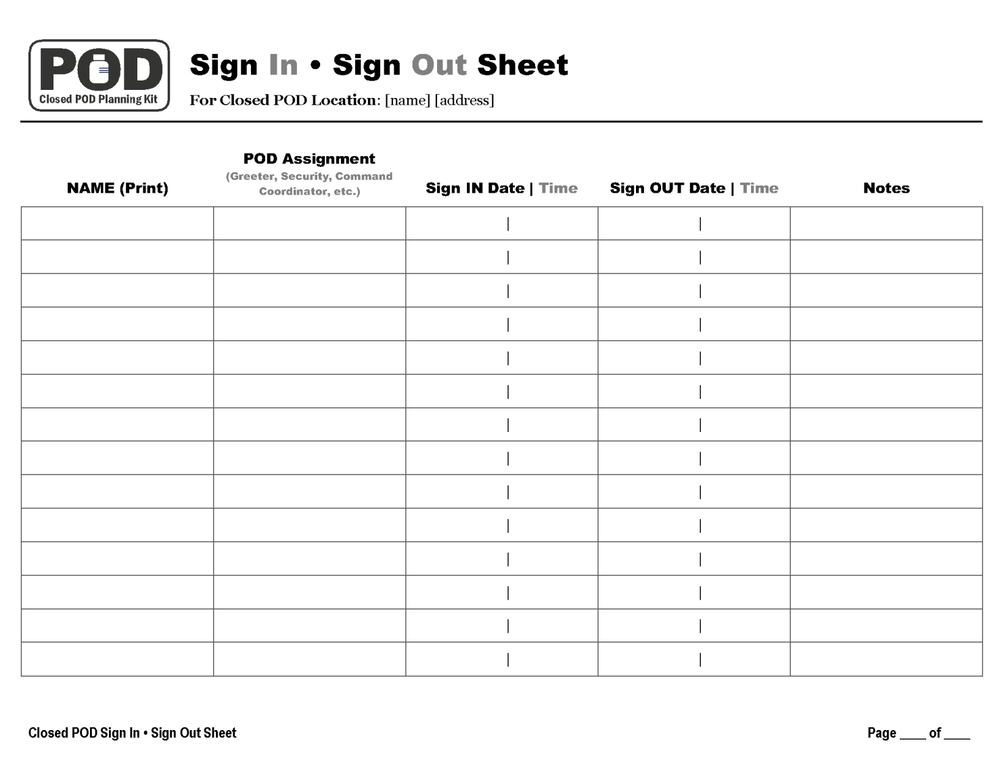

Appendix C • Closed POD Scheduler
The following is an example scheduler. See Forms – Closed POD Scheduler in Closed POD Planning Kit, Closed POD Operations folder, for an editable form.

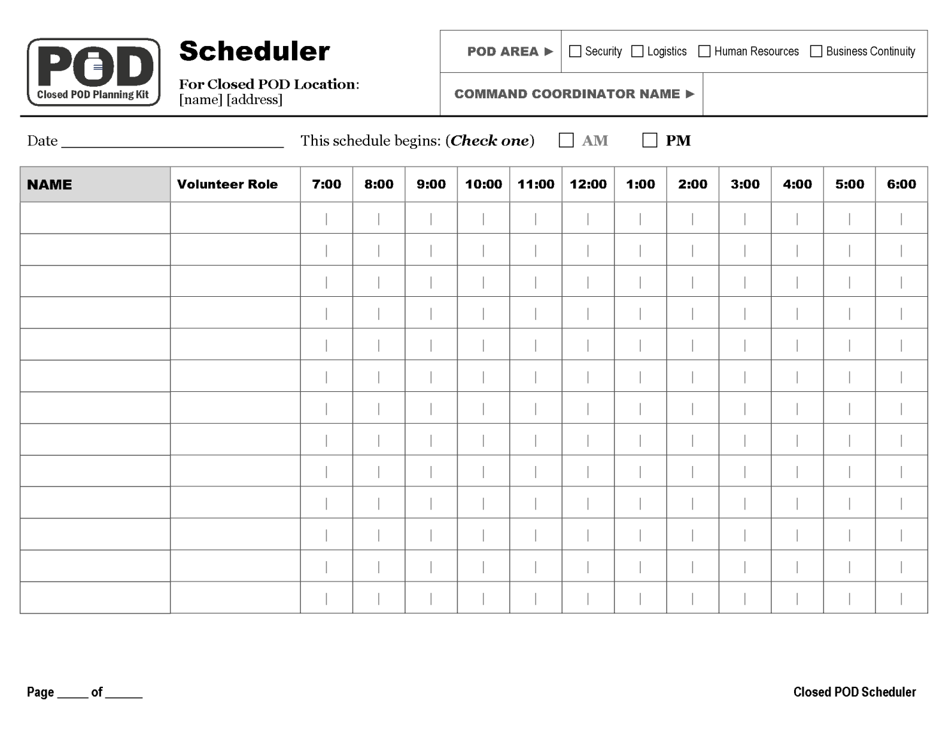

Appendix D • Medication Screening Form
The following is an example screening form. See Forms – Medication Screening Form in Closed POD Planning Kit, Closed POD Operations folder, for an editable form. Also, see the Property/DOH Discussion Guide in the Closed POD Planning Kit, Planning Tools folder, to know which medications your property will distribute.

