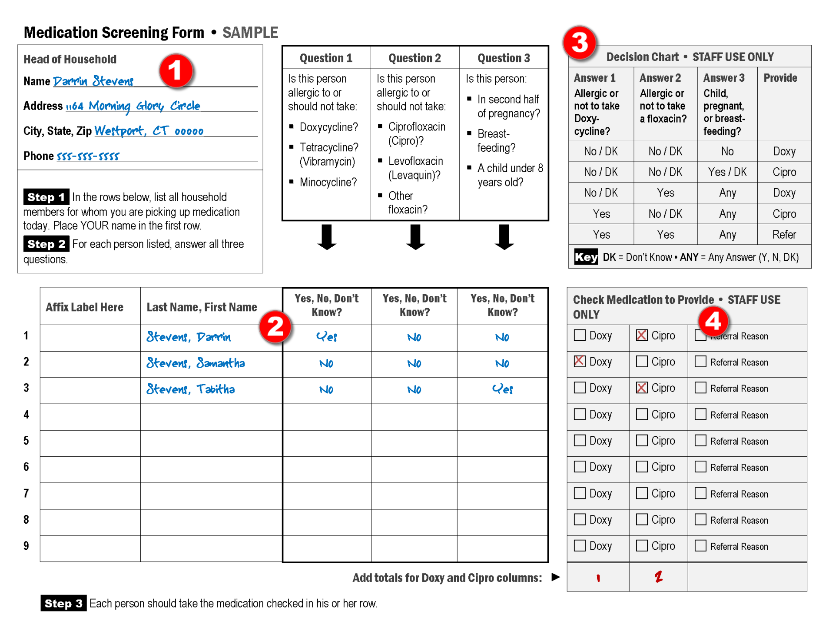

Medication Screening Form • Job Aid

Understanding Dispensing Consideration
The first step in medication dispensing is screening each recipient to ensure that each person gets the right medication at the right time in the right dose.
On the reverse is a sample completed Medication Screening Form.
NOTE: The form provided by your local public health department may look slightly different, but will have the same elements.
The form is designed for one person (designated head of household) to pick up medication for multiple people. To use the most efficient process and avoid potential errors on the form, complete and double-check each person’s row completely before going on to the next row.

Reminders
- Before handing the bottle of medication to the recipient, peel off the appropriate label and affix it in the box labeled Affix Label Here (to the left of the recipient’s name).
- Print the recipient’s name on the bottle with a Sharpie®.
- If children are listed on the form, make sure the recipient has the Children Dosing Information.
- Tell each recipient to take his/her medication right away.
- If a recipient has additional questions, tell him/her to call his/her physician or the public health department.

Illustration Reference
 | Make sure that the Head of Household information is complete in the upper left hand corner.
 | In the list of recipients:  - Make sure that all names are legible.  - Confirm those who are listed as children under the age of 8. (The column corresponding to Question 3 reads “Yes” when a child is under the age of 8).  - Confirm those who are listed as pregnant or breastfeeding. (The column corresponding to Question 3 reads “Yes” when a woman is pregnant/breast-feeding.)  - Confirm that none of the listed names are for pets or service animals.
 | - Use the shaded Decision Chart in the upper right-hand corner to determine which medication a recipient should receive.  - To identify and dispense the proper medication, find the line in the Decision Chart that matches the listed answers.
 | - On the recipient’s row, put a checkmark in the box next to the proper medication.  - If the “Provide” column in the Decision Chart indicates “Refer,” check the box labeled “Referral Reason” and make a brief notation explaining why.  - At the bottom of the form, calculate the total bottles of each medication.

